NYU Tandon School of Engineering
Computer Science and Engineering

TutorLink

Software System Design Specification (SSDS)

Version 3.0
Document Number: SSDS-001

Project Team Number: B8

Project Team Members:
Alan Zhang (yz10074)
Erfu Hai (eh3323)
Michael Bian (zb2253)
David Rokicki (dr3492)

Version 2.0 February 19, 2026

Review and Approvals

Printed Name and Title | Function | Date | Signature
Alan Zhang | Author | 2026/2/17 | Alan Zhang
Michael Bian | Author | 2026/2/17 | Michael Bian
David Rokicki | Reviewer | 2026/2/18 | David Rokicki
Erfu Hai | Approval | 2026/2/18 | Erfu Hai

Revision Level

Date | Revision Number | Purpose
Jan 20, 2026 | Version 1.0 | Initial Release
Feb 19, 2026 | Version 2.0 | Domain Deliverable - Sections 1-7 completed for TutorLink
Mar 5, 2026 | Version 3.0 | Requirements/Analysis - Sections 8-9 completed for TutorLink

Table of Contents

1. Document Purpose
1.1 Purpose
2. Introduction
2.1 Scope
2.2 Identification
2.3 Bounds
2.4 Objectives
2.5 Context Diagram
2.6 Additional Descriptive Items
3. Glossary
4. Reference Documents
5. Business Requirements
5.1 Technology
5.2 Economics
5.3 Regulatory and Legal
5.4 Market Considerations
5.5 Risks and Alternatives
5.6 Human Resources and Training
6. User Requirements (Descriptive, Functional, and Non-Functional Requirements)
6.1 Functional Descriptive Detailed Requirements
6.2 Non-Functional Descriptive Detailed Requirements
7. System Architecture
8. Detailed System Requirements – Use Cases
8.1 Requirement Use Cases
8.1.1 Use Case Diagrams
8.1.2 Use Case Descriptions
9. System Model (UML)
9.1 Static-Class Diagrams
9.2 Dynamic - Behavioral Models
10. System-Wide Design Decisions
10.1 Software Component Architectural Design
10.2 Software Architecture General Description
10.3 Software Item Components
10.4 Component Interface Identification
10.5 Software Component Concept of Execution
11. Software Item Detailed Design
11.1 Structure
11.2 Static Relationship of Software Unit
11.3 Behavior
11.4 Concept of Execution
11.5 Interface Design
12. Deployment Architecture
12.1 Physical Deployment Architecture Diagram
13. Evolution of the SSDS
14. Rationale
15. Notes
16. Appendices
16.1 System Test Plan Requirements
16.2 Qualification Provisions
16.3 Requirements Traceability
16.4 Schedule Tracking
16.5 Defect Tracking
16.6 Dictionaries
17. Index

1. DOCUMENT PURPOSE

1.1 Purpose
This Software System Design Specification (SSDS) specifies the requirements, analysis and design of the TutorLink system. It is the main technical blueprint for the project team and ensures that there is a common understanding of the system to be built.
The intended audience for this document includes the project development team (Team B8), the course instructor (Professor Strauss), and any future developers who may maintain or extend the system.

2. INTRODUCTION

The system to be produced is TutorLink, a peer-to-peer tutoring marketplace that is designed for university communities. The main customer problem is the challenge students have in locating accessible, convenient and approachable academic support. Official resources such as Teaching Assistants (TAs) can be scary and university tutoring centers are often strict in their schedules and inconvenient in their location.
TutorLink will fix this by developing a platform where students can easily connect with qualified peer tutors from their own school. The application will simplify the entire process, from a student posting a request for help to finding an appropriate tutor, scheduling a session, and creating a trusted academic support network.
The benefits at the top of the list are better academic results for students, valuable teaching experience and income for tutors, and the creation of a more collaborative learning environment within the university. This is in line with our project objective to promote inclusive and equitable quality education (UN SDG Goal 4).
From the product standpoint, TutorLink is a stand alone system. It is not part of a larger software suite and is designed to be used by itself. Its main external interface is to a standard email service for verifying user identity based on their University email address (@school.edu).

2.1 Scope
Functionality INCLUDED in the system:
• User registration and authentication using a university-provided email address (e.g., @nyu.edu).
• Distinct user profiles for Tutors and Tutees.
• A feature for Tutees to create, post, and manage tutoring requests (specifying subject, time, location, budget).
• A searchable marketplace for Tutors to browse and apply for tutoring requests.
• An internal messaging system for users to communicate and coordinate sessions.
• A scheduling feature to finalize and track tutoring appointments.
• A reputation system based on ratings and reviews for both Tutors and Tutees.
• A student-driven verification flow where Tutors can optionally upload their transcript to earn Verified Course Badges.

Functionality NOT INCLUDED in the system:
• Direct integration with any university information systems (SIS) to access student records (e.g., grades, transcripts, enrollment data).
• In-app payment processing. All financial transactions are to be handled directly between the Tutor and Tutee outside the platform.
• Real-time video conferencing or virtual classroom features. The platform is for connection and scheduling, not live instruction delivery.

2.2 Identification
Document Name: TutorLink Software System Design Specification (SSDS)
Document Number: SSDS-001
Revision: Version 2.0

2.3 Bounds
The system is a web and mobile self-contained application. It is bound by the legal constraints of the Family Educational Rights and Privacy Act (FERPA) that dictates that the system cannot access student education records from the university. All verification data must be provided by the student. The system works in the digital system of the university community, using the university email domain (e.g. @nyu.edu) as a boundary for membership verification.

2.4 Objectives
Project Priority: High
Type of Delivery: Evolutionary, with three main phases corresponding to the SSDS deliverables (Domain, Requirements/Analysis, and Design).
Life Cycle: Incremental
Initial Deliverable (Milestone) Dates:
• SSDS - Domain: February 19, 2026
• SSDS - Requirements/Analysis: March 5, 2026
• SSDS - Design: April 23 – May 5, 2026
• Implementation: April 23 – May 5, 2026
• Presentation and Demonstration: April 23, 2026

2.5 Context Diagram
The following context diagram gives an overview of the TutorLink system and defines all the significant interfaces that cross the system boundaries. The system interacts with three external entities: Student as a Tutee, Student as a Tutor and the University Email Service for identity verification.

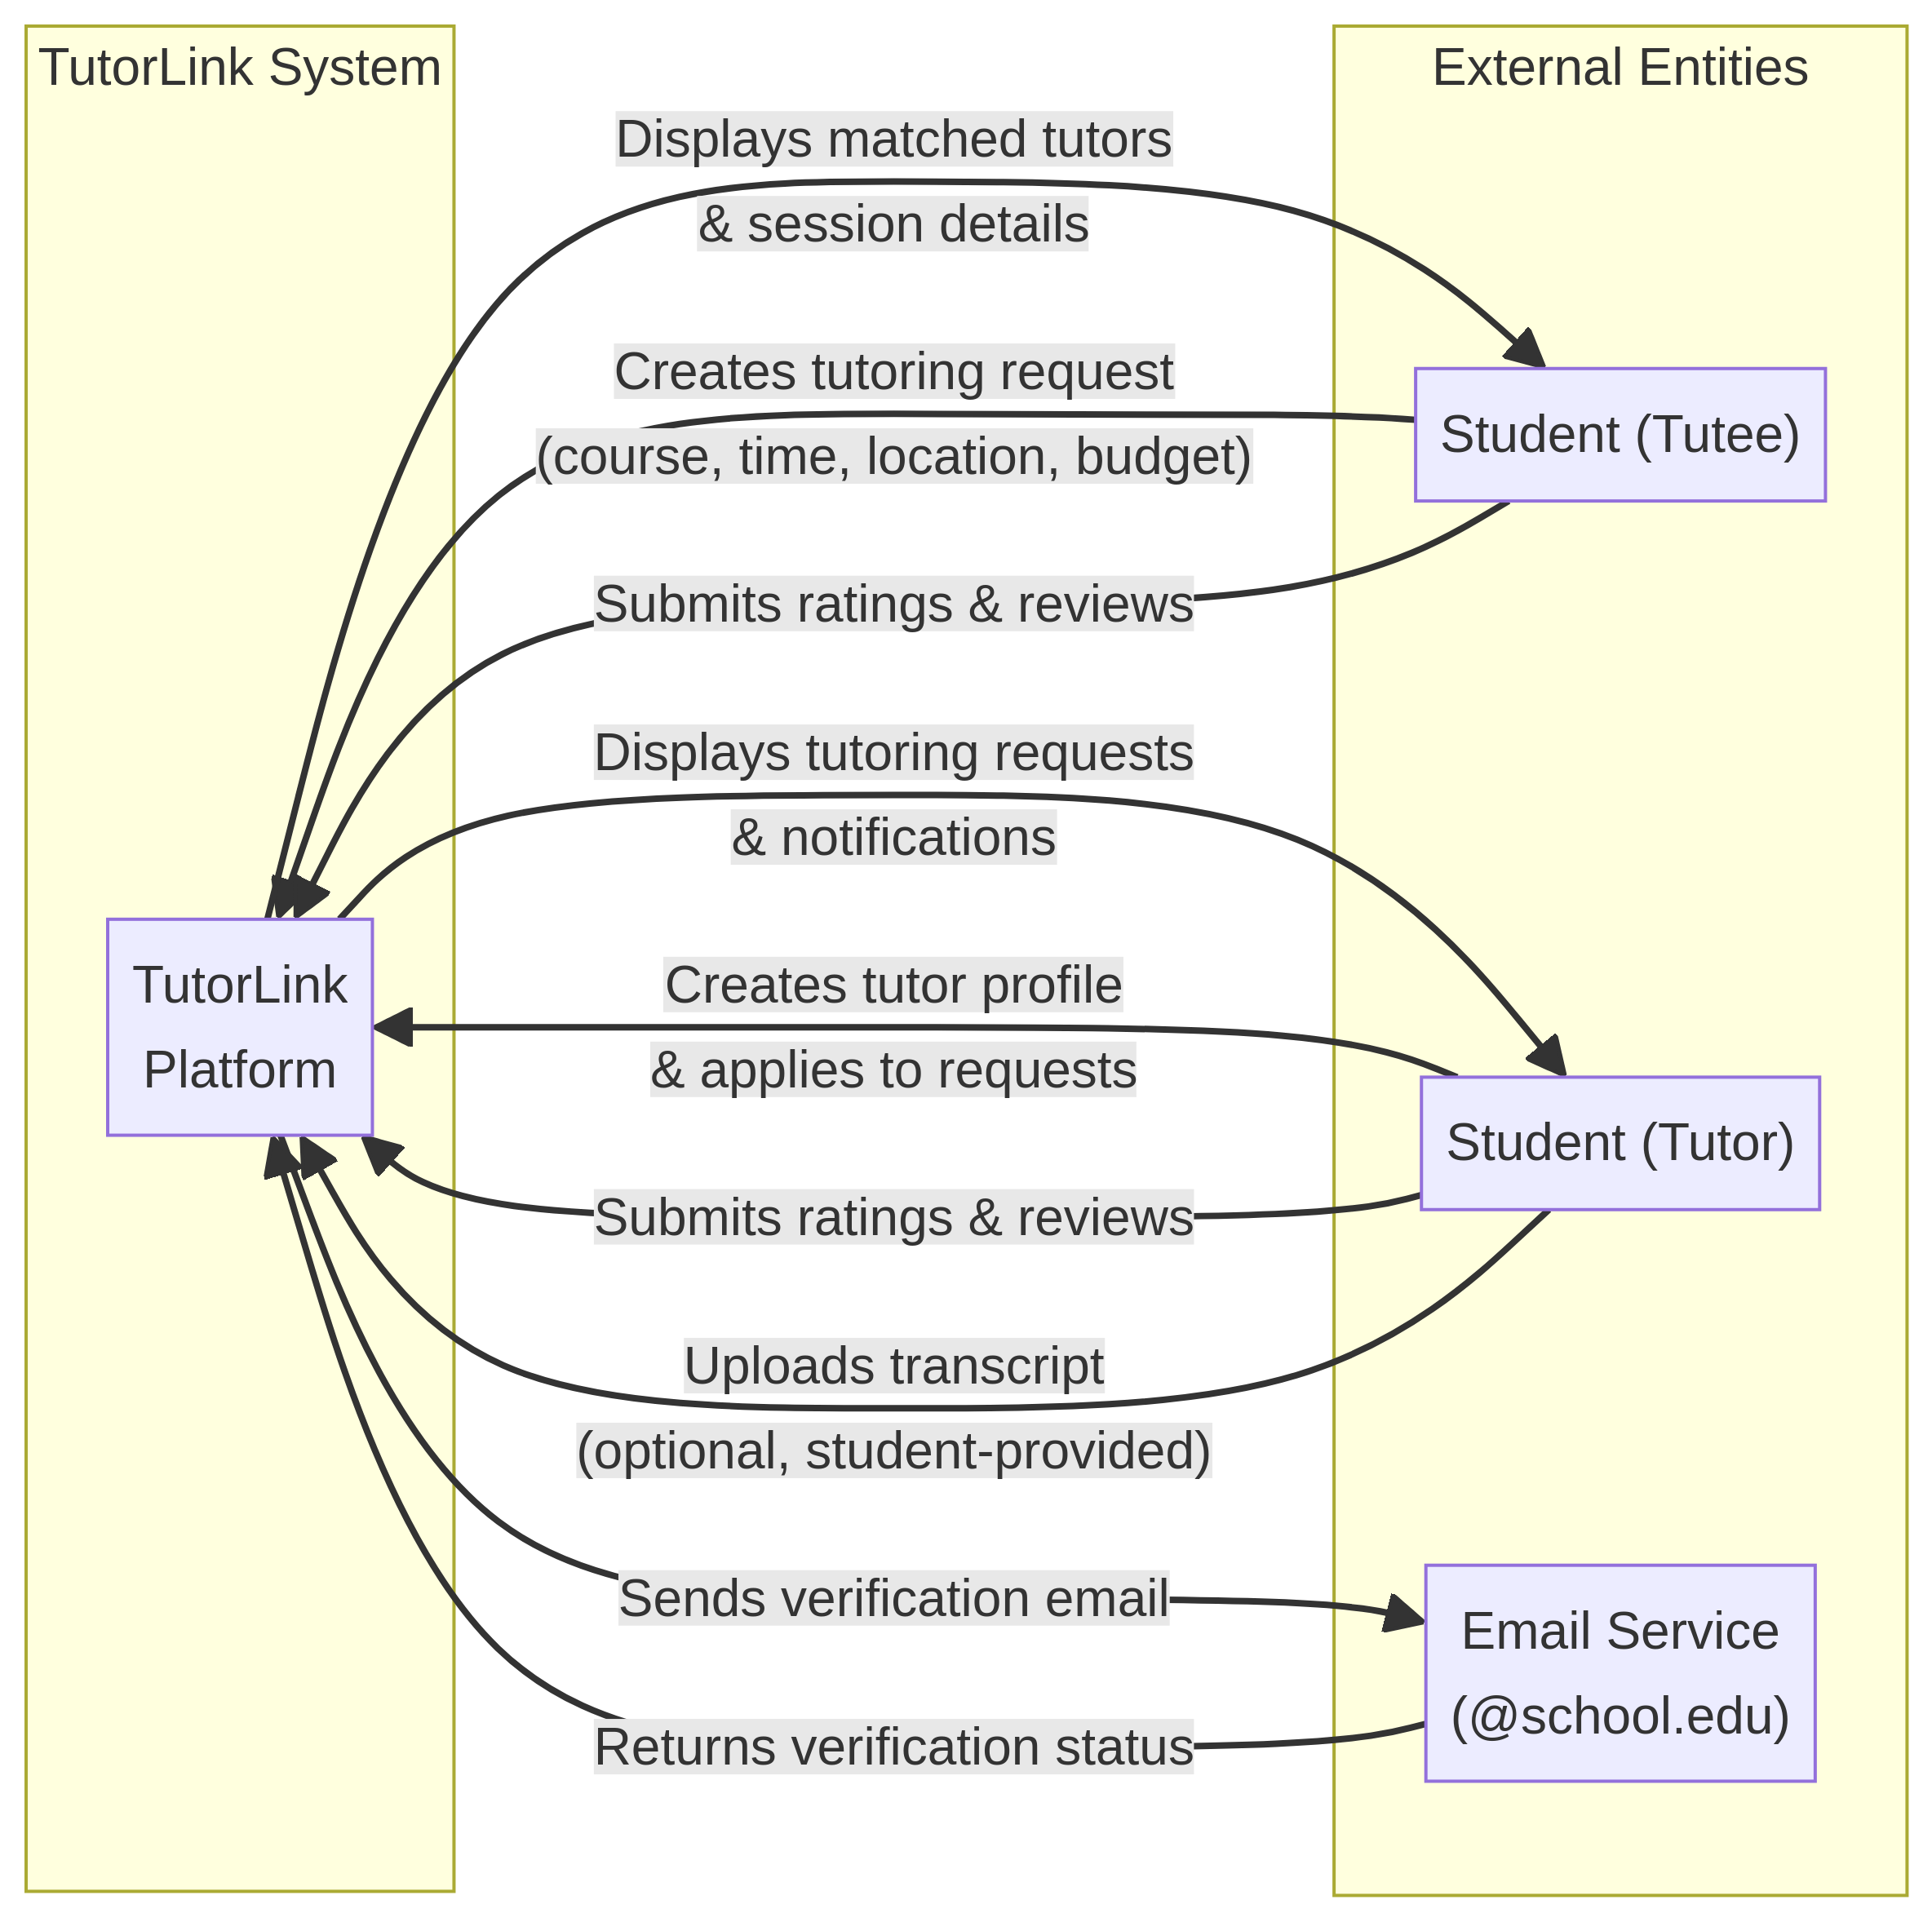

2.6 Additional Descriptive Items
a. Product Functions: TutorLink has the following main functionality: user registration and email-based verification, tutor and tutee profile management, tutoring request creation and browsing, matching algorithm to find a suitable tutor for a tutee, in-app messaging, session scheduling, and a reputation system based on ratings and reviews.
b. User Characteristics: The intended users are the students of New York University, both undergraduate and graduate students. They are expected to be tech-savvy and comfortable with the use of web and mobile applications. No special technical know-how is needed to use the platform.
c. Constraints:
• Regulatory: The system must strictly follow the guidelines of FERPA. TutorLink will not integrate with University systems to pull transcripts, grades, or other education records. Any proof of course completion or performance is given directly by the student.
• Development Language: The specific technology stack is to be determined but will likely consist of a modern web framework for the frontend and a server-side runtime for the backend, paired with a relational database.
• Safety and Security: User authentication should be secure. All user-supplied information (particularly uploaded transcripts) must be treated with extreme privacy restrictions. Students can redact irrelevant information from uploaded documents and the system will store only the minimum data necessary to display verified course badges.
d. Assumptions and Dependencies: We assume that students will be willing to use a peer-to-peer tutoring platform and will give generally honest information in their profiles and reviews. The system relies on the email service provided by the university for the initial verification of user affiliation with the university.
e. Requirements Subsets: For the first release, the basic functionality (registration, profiles, request posting, browsing and messaging) will take precedence. Advanced features such as the matching algorithm refinement and the verified course badge system can be delivered in the future.

3. GLOSSARY

Term | Definition
FERPA | The Family Educational Rights and Privacy Act, a U.S. Federal law that protects the privacy of student education records.
Reputation System | The mechanism within TutorLink for building user credibility, based on profiles, peer reviews, and ratings.
SSDS | Software System Design Specification. The comprehensive design document for the project.
Tutee | A student seeking academic assistance through the TutorLink platform.
Tutor | A student offering academic assistance and mentorship through the TutorLink platform.
TutorLink | The name of the peer-to-peer tutoring marketplace software system being developed.
Verified Course Badge | A digital badge on a Tutor's profile indicating that they have provided student-submitted documentation (e.g., a transcript) to verify their successful completion of a specific course.

4. REFERENCE DOCUMENTS

Team Number | Document Name | Document Number | Version | Date
B8 | TutorLink Project Proposal (FERPA-fixed) | PP-001 | 1.1 | Feb 10, 2026

5. BUSINESS REQUIREMENTS

5.1 Technology
The main technology driver is the adoption of smartphones and web applications by university students. TutorLink takes advantage of this by offering a web interface as well as a mobile interface. The platform should support modern browsers and the mobile operating systems (iOS and Android). No proprietary/specialized hardware is required.

5.2 Economics
This project is an academic requirement for CS-UY 4523, and has no direct commercial economic drivers. The TutorLink platform itself will be free of charge for students. The economic model is a peer-to-peer one - tutors are free to set their own rates, and payment is made directly between tutor and tutee, outside the platform. There are no commission or transaction fees charged by TutorLink.

5.3 Regulatory and Legal
The major regulatory constraint is the Family Educational Rights and Privacy Act (FERPA). FERPA forbids educational institutions from releasing student education records to third parties without the express consent of the student. To comply, TutorLink has a strict policy, the platform will NOT integrate with any university systems to pull transcripts, grades or other education records. All verification data is provided on a voluntary and direct basis by the student. Students can redact irrelevant information from uploaded documents and only the minimum data necessary to display verified course badges is stored in the system.

5.4 Market Considerations
The target "market" is the NYU student body, though the platform is designed to be scalable to other university communities. The system solves a definite and unfulfilled need for a more flexible, affordable and less intimidating tutoring solution than the current options such as TAs and university tutoring centers. Competitive alternatives exist in the form of generic freelance platforms (e.g. Wyzant, Chegg Tutors), but these do not have the community-specific, peer-to-peer focus TutorLink offers.

5.5 Risks and Alternatives
The following table identifies key system risks and their mitigation plans:

Risk Type | Description | Probability | How Discovered | Responsible Party | Status | Mitigation Plan
Business | Low user adoption. Students may prefer existing habits or not trust a new platform. | Medium | Market research and team discussion | Team B8 | Open | Implement intuitive UI/UX. Promote through student channels. Emphasize trust features (@nyu.edu verification).
Operational | Disputes between users over payment, session quality, or conduct. | Medium | Analysis of similar platforms | Team B8 | Open | Implement rating/review system. Provide clear community guidelines. Use reputation system to flag problematic users.
Technology | Matching algorithm may not effectively connect tutees with the best tutors. | Low | Technical design review | Team B8 | Open | Begin with simple matching based on course codes. Refine algorithm based on user feedback and match data.
Regulatory | Accidental FERPA violation through a feature that inadvertently accesses or stores university records. | Low | Legal review of project proposal | Team B8 | Mitigated | All features reviewed against student-provided data principle. No direct integration with university systems.

5.6 Human Resources and Training
The project is to be developed by the four members of Team B8: Alan Zhang, Erfu Hai, Michael Bian and David Rokicki. No additional human resources are needed. Team members may have to self-train in specific technologies selected for implementation (e.g. a particular frontend framework or database system), but no formal external training is expected.

6. USER REQUIREMENTS (DESCRIPTIVE, FUNCTIONAL, AND NON-FUNCTIONAL REQUIREMENTS)
This section defines all software requirements for the TutorLink system in sufficient detail to enable designers to build a conforming system and testers to verify it. All requirements are externally observable behaviors as perceived by users, operators, or external systems. Each requirement is uniquely identified (REQ-F-xx or REQ-NF-xx), cross-referenced to the project proposal or earlier SSDS sections, and organized for readability.
6.1 Functional Descriptive Detailed Requirements

FR-1: User Registration and Authentication
Definition: The system must allow students to create accounts and securely log in using their university-issued email address.
Specifications:
REQ-F-01: The system shall allow a new user to register by providing a university email address (e.g., @nyu.edu) and a password. [Ref: Proposal §2, Scope §2.1]
REQ-F-02: The system shall send a verification email to the provided university address, and the account shall not be activated until the link is confirmed. [Ref: Scope §2.1]
REQ-F-03: The system shall allow registered users to log in using their email and password.
REQ-F-04: The system shall support password reset via a link sent to the registered email address.
REQ-F-05: The system shall restrict account creation to email addresses from recognized university domains; non-university addresses shall be rejected.

FR-2: User Profile Management
Definition: The system must allow both Tutors and Tutees to create, edit, and view detailed profiles that represent their academic background, expertise, and preferences.
Specifications:
REQ-F-06: Upon registration, the system shall prompt the user to select a role: Tutor or Tutee (or both). [Ref: Proposal §2]
REQ-F-07: A Tutor profile shall include: display name, self-reported courses taken, areas of expertise, hourly rate, availability, and a short bio.
REQ-F-08: A Tutee profile shall include: display name, subject areas needing help, preferred meeting format (in-person / virtual), and availability.
REQ-F-09: Tutors shall be able to optionally upload a transcript or grade report. The system shall display a "Verified Course Badge" on the tutor's profile upon upload. The system shall store only the minimum data required to display this badge and shall never share the document. [Ref: Proposal §2, FERPA note; Bounds §2.3]
REQ-F-10: Users shall be able to update their profile information at any time.

FR-3: Tutoring Request System
Definition: The system must allow Tutees to post, manage, and close tutoring requests, and allow Tutors to browse and apply to those requests.
Specifications:
REQ-F-11: The system shall allow a Tutee to create a tutoring request specifying: course/subject, topic description, availability time slots, preferred meeting format, and budget range. [Ref: Proposal §2]
REQ-F-12: Posted requests shall be visible to all registered Tutors.
REQ-F-13: The system shall allow a Tutor to submit an application to any open request.
REQ-F-14: The Tutee shall be able to view all applications received for their request, including each applicant's profile and rating.
REQ-F-15: The Tutee shall be able to accept one application, which transitions the request to "In Progress" status, and the system shall notify the accepted Tutor.
REQ-F-16: The Tutee shall be able to close or delete their own requests at any time.

FR-4: Matching Algorithm
Definition: The system must provide an intelligent ranking of Tutor applicants for each Tutoring Request based on compatibility criteria.

Specifications:
REQ-F-17: When a Tutee views applications for their request, the system shall rank applicants using a scoring function that considers: expertise match (self-reported courses vs. requested subject), schedule overlap, location/format preference alignment, and budget alignment. [Ref: Proposal §2, Matching Algorithm]
REQ-F-18: The system shall surface Tutors with higher overall ratings higher in the ranked list, all else being equal.
REQ-F-19: The system shall notify Tutors via in-app notification when a new request is posted that matches their stated areas of expertise.
REQ-F-20: The matching score shall be computed server-side; the algorithm logic shall not be exposed to end users.

FR-5: In-App Messaging and Scheduling
Definition: The system must provide a secure, in-app communication channel between matched Tutors and Tutees and a calendar feature for managing sessions.

Specifications:
REQ-F-21: Once a Tutor's application is accepted, the system shall open a private messaging thread between that Tutor and Tutee. [Ref: Proposal §2, Key Features]
REQ-F-22: Messages shall support plain text. Message history shall be stored and retrievable by both parties for the duration of the session.
REQ-F-23: The system shall allow either party to propose a session date/time within the messaging interface.
REQ-F-24: Confirmed sessions shall appear on a scheduling calendar view accessible from the user's dashboard.
REQ-F-25: The system shall send an in-app reminder notification to both parties 24 hours before a scheduled session.

FR-6: Rating, Review, and Reputation System
Definition: The system must allow both Tutors and Tutees to rate and review each other after a completed session, forming the platform's trust mechanism.

Specifications:
REQ-F-26: After a session is marked complete, the system shall prompt both the Tutor and the Tutee to submit a rating (1–5 stars) and an optional text review of the other party. [Ref: Proposal §2, Reputation System]
REQ-F-27: Submitted ratings and reviews shall be displayed publicly on the reviewed user's profile.
REQ-F-28: The system shall compute and display an aggregate average rating on each user's profile, updated after each new review.
REQ-F-29: Users shall not be able to edit or delete reviews they have submitted.
REQ-F-30: The system shall allow a user to report a review that they believe violates platform guidelines; a flagged review shall be hidden pending manual review.

6.2 Non-Functional Descriptive Detailed Requirements

Non-functional requirements define the quality attributes and constraints under which the TutorLink system must operate. The following taxonomy categories are used: Performance, Usability, Reliability, Security, Maintainability, and Compliance.

NFR-1: Performance
REQ-NF-01: The system shall return search results and load profile pages within 2 seconds under normal load (up to 200 concurrent users).
REQ-NF-02: The matching algorithm shall complete its ranking computation and return results within 3 seconds for any single tutoring request.
REQ-NF-03: In-app messages shall be delivered within 5 seconds of being sent under normal network conditions.

NFR-2: Usability
REQ-NF-04: A new user shall be able to complete registration and post or apply to their first tutoring request within 10 minutes without external assistance.
REQ-NF-05: The user interface shall be responsive and functional on modern desktop browsers (Chrome, Firefox, Safari) and on mobile devices with screen widths of 375px and above.
REQ-NF-06: All error messages presented to the user shall be written in plain language and indicate a corrective action (e.g., "Email format is invalid. Please use your @nyu.edu address.").

NFR-3: Reliability
REQ-NF-07: The system shall target an uptime of at least 99% during the academic semester (excluding scheduled maintenance windows).
REQ-NF-08: The system shall preserve all in-progress messaging threads and user data in the event of a non-catastrophic server failure, with recovery possible within 1 hour.
REQ-NF-09: The system shall implement automated database backups at least once every 24 hours.

NFR-4: Security
REQ-NF-10: All user passwords shall be stored using a strong cryptographic hash function (e.g., bcrypt); plaintext passwords shall never be stored or logged.
REQ-NF-11: All data in transit between the client and server shall be encrypted using HTTPS/TLS.
REQ-NF-12: Uploaded transcript files shall be stored in a private, access-controlled storage bucket. Files shall not be publicly accessible via URL and shall only be retrieved by authenticated backend processes. [Ref: Proposal §2 FERPA note; Bounds §2.3]
REQ-NF-13: The system shall implement session token expiration; inactive sessions shall expire after 30 minutes of inactivity.

NFR-5: Maintainability
REQ-NF-14: The backend codebase shall include inline documentation (comments) for all public API endpoints and core business logic functions.
REQ-NF-15: The system shall be designed with a modular architecture (e.g., separate modules for authentication, matching, messaging, and reviews) to allow independent updates to each component. [Ref: Scope §2.1]
REQ-NF-16: The system shall use a version control system (Git) with meaningful commit messages; all source code shall be maintained in a shared team repository.

NFR-6: Compliance
REQ-NF-17: The system shall not access, store, or transmit any student education records from university systems. All academic credential information entered into TutorLink must be voluntarily submitted by the student themselves. [Ref: Regulatory §5.3; Bounds §2.3; Proposal §2 FERPA note]
REQ-NF-18: Transcript uploads shall be used solely to award a Verified Course Badge on the Tutor's profile. The raw file shall not be displayed to other users, and only the minimum metadata required for the badge (course names confirmed) shall be stored.
REQ-NF-19: The system shall present users with a privacy notice at registration that clearly describes what data is collected, how it is used, and that voluntary transcript uploads are processed solely for badge verification.

7. SYSTEM ARCHITECTURE

This section presents a high-level overview of the TutorLink system architecture, describing how core functions are distributed across system modules and identifying reused or shared architectural components.

7.1 Architectural Style

TutorLink follows a three-tier client-server architecture:

- Presentation Tier: A responsive web/mobile front-end (React-based SPA) that renders the user interface and communicates with the backend exclusively through RESTful API calls.
- Application Tier: A Node.js/Express backend server that implements all business logic, including authentication, matching, messaging, and review processing.
- Data Tier: A relational database (PostgreSQL) that persists all system data, supplemented by a private file storage service for uploaded transcript documents.

This separation of concerns ensures that each tier can be developed, tested, and scaled independently. [Ref: Maintainability REQ-NF-15; Scope §2.1]

7.2 System Module Overview

The backend application tier is organized into the following loosely coupled modules. Each module owns a distinct functional area and exposes a defined internal interface to the other modules.

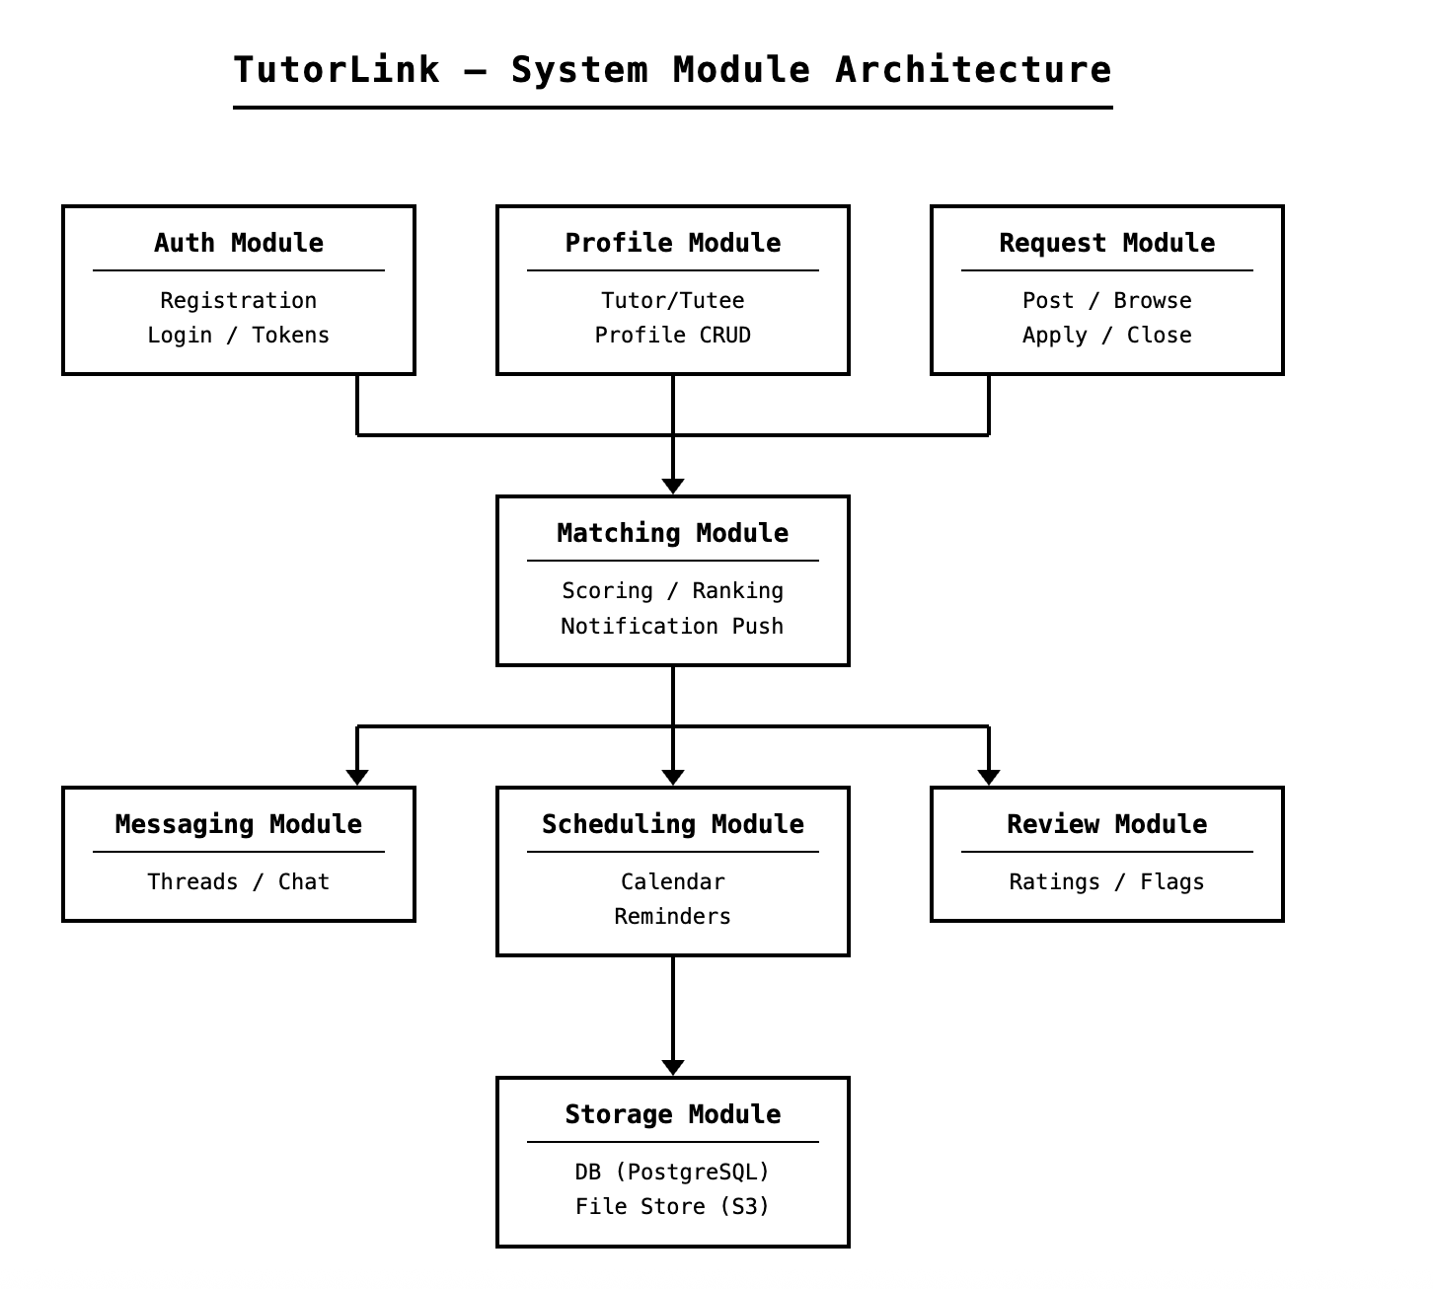

7.3 Module Descriptions

Auth Module
Responsible for user registration, email-based university domain validation, password hashing (bcrypt), JWT session token issuance, and token expiration. All other modules require a valid token to be present before processing any request. [Ref: REQ-F-01 to REQ-F-05; REQ-NF-10, REQ-NF-13]

Profile Module
Manages creation and updates of Tutor and Tutee profiles, including self-reported course/expertise data and availability. Handles the optional transcript upload workflow: receives the file, forwards it to the Storage Module, and triggers badge assignment upon successful upload. The raw file is never exposed to the Presentation Tier after upload. [Ref: REQ-F-06 to REQ-F-10; REQ-NF-12, REQ-NF-17, REQ-NF-18]

Request Module
Handles the full lifecycle of tutoring requests: creation, publication to the marketplace, application submission by Tutors, acceptance by Tutees, and closure. Emits an event to the Matching Module when a new request is published. [Ref: REQ-F-11 to REQ-F-16]

Matching Module
Consumes request and profile data to compute a compatibility score for each Tutor applicant using four weighted criteria: expertise match, schedule overlap, location/format preference, and budget alignment. Returns a ranked list to the Request Module for display. Also subscribes to new request events and dispatches in-app notifications to relevant Tutors. [Ref: REQ-F-17 to REQ-F-20; REQ-NF-01, REQ-NF-02]

Messaging Module
Manages private message threads created upon a successful match. Stores message history in the database and delivers new messages to connected clients. Provides the session proposal interface consumed by the Scheduling Module. [Ref: REQ-F-21 to REQ-F-23; REQ-NF-03]

Scheduling Module
Maintains session records (confirmed date/time, location, participants). Integrates with the Messaging Module for session proposals and triggers a 24-hour reminder notification for upcoming sessions. [Ref: REQ-F-24 to REQ-F-25]

Review Module
Activated when a session is marked complete. Collects star ratings and text reviews from both parties, persists them, and updates each user's aggregate rating. Supports flagging of reviews for moderation. [Ref: REQ-F-26 to REQ-F-30]

Storage Module
A shared infrastructure module providing two services: (1) PostgreSQL database access via a connection pool used by all other modules, and (2) a private S3-compatible object store for transcript files. No other module accesses the file store directly. [Ref: REQ-NF-09, REQ-NF-12]

7.4 Reused Architectural Components

The following standard or third-party components are reused across multiple modules rather than being re-implemented:

- JWT Library: Used by the Auth Module and validated by all other modules as a shared authentication middleware layer.
- Email Service (e.g., SendGrid): Shared by the Auth Module (verification emails, password reset) and the Scheduling Module (session reminders), invoked through a single notification utility.
- Environment Configuration Manager: A centralized config module that supplies database credentials, storage keys, and API secrets to all modules via environment variables, preventing hardcoded secrets in source code. [Ref: REQ-NF-14]

7.5 Data Flow Summary

A typical end-to-end interaction follows this path:

1. Client (Presentation Tier) sends an HTTPS request with a JWT to the Application Tier.
2. Auth middleware validates the token; the request is routed to the appropriate module.
3. The module executes business logic, reads from or writes to the Data Tier via the Storage Module.
4. The module returns a JSON response to the Presentation Tier.
5. For asynchronous events (notifications, reminders), the relevant module publishes an internal event; the notification utility dispatches the message to the target user.

All communication between the Presentation Tier and the Application Tier is over HTTPS/TLS. Internal module-to-module communication occurs in-process within the same server runtime. [Ref: REQ-NF-11]

8. DETAILED SYSTEM REQUIREMENTS – USE CASES

This section provides a comprehensive description of how the system behaves from the user's perspective, in the form of use cases. Every use case is a goal which an actor, who can be a user or external system, can attain through interaction with TutorLink. These descriptions give the functional scope of the system in a narrative way, which is clear on how the users will achieve their goals.
8.1 Requirement Use Cases
The use case diagrams and detailed use case descriptions of the TutorLink system are provided in the following subsections. All use cases are presented in the Use Case diagram, and each of them has its Use Case description. The use cases are based directly on the functional requirements of Section 6 and address the entire lifecycle of a tutoring interaction, including account creation, session completion, and review.
8.1.1 Use Case Diagrams
The diagram below shows the main applications of the two main actors of the TutorLink system: the Tutee and the Tutor. It gives a detailed summary of the main interactions that each type of user will have with the system, starting with registration and ending with the tutoring session and submission of a review. All fourteen identified use cases are within the system boundary, whereas the external Email Service actor is involved in the verification workflow. Both types of actors can access shared use cases, including logging in, profile management, messaging, scheduling, and reviewing, which is indicative of a symmetric trust model of the platform.
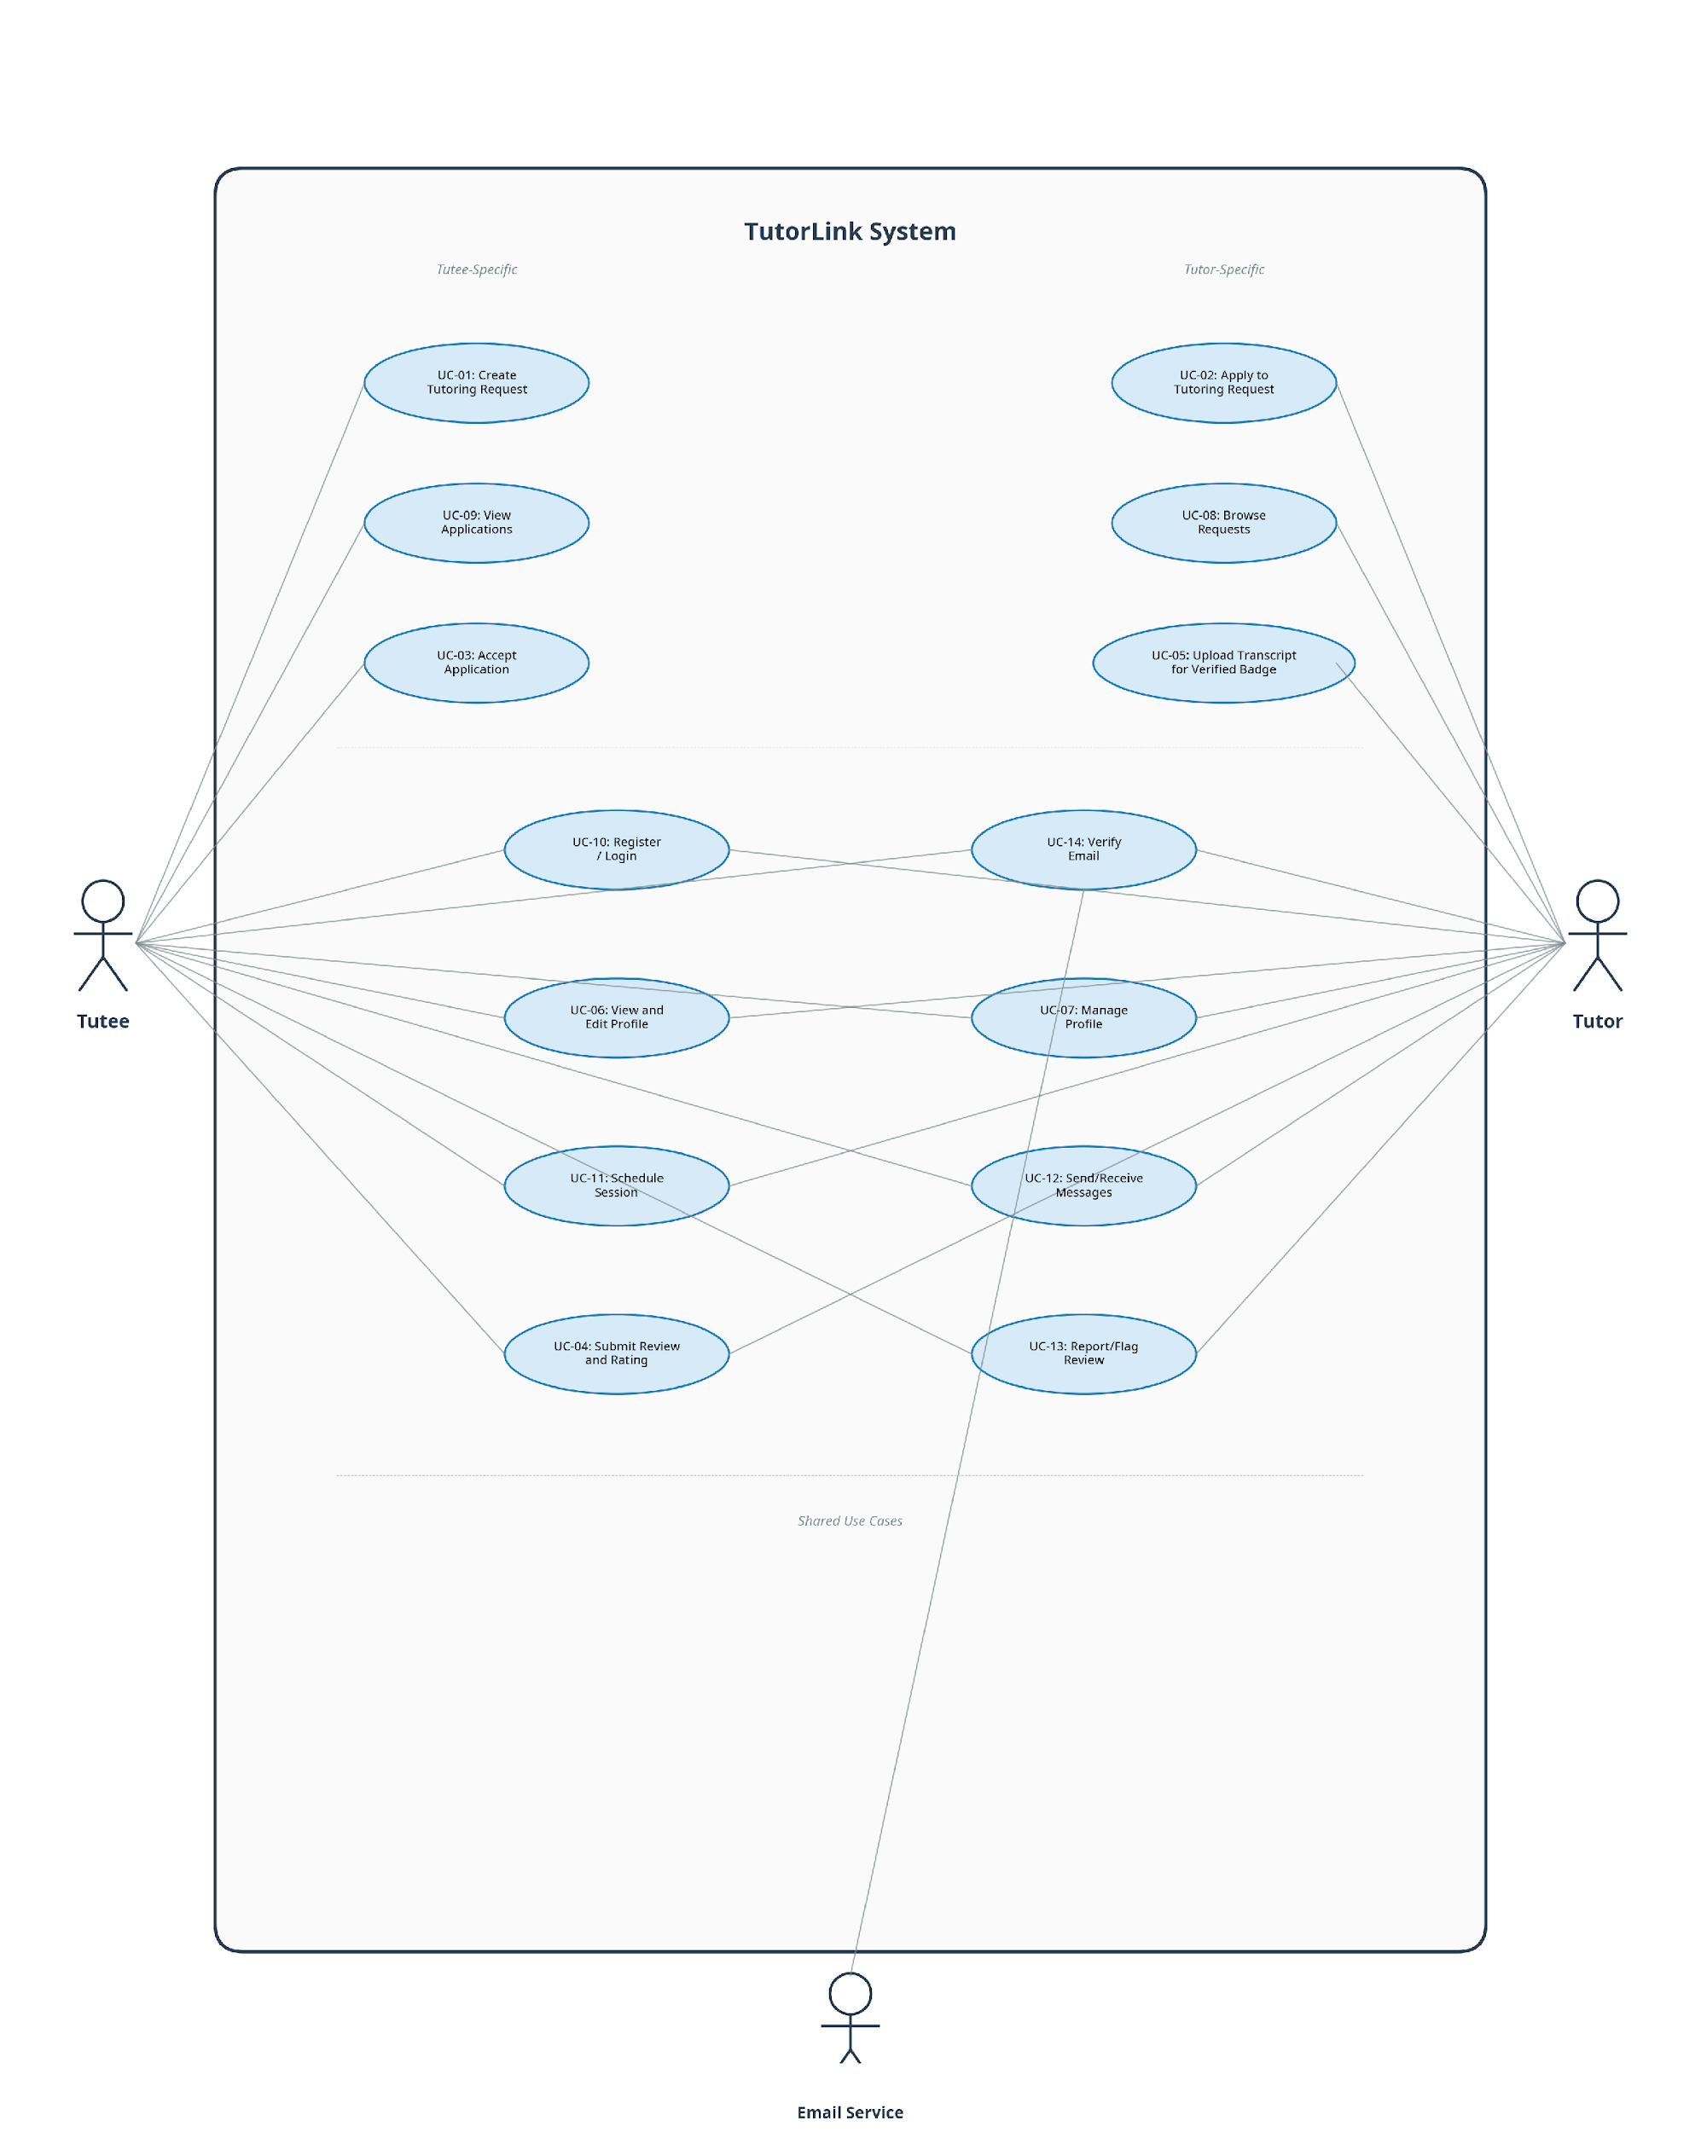

8.1.2 Use Case Descriptions
Below are detailed narrative descriptions for the five most critical use cases identified in the TutorLink system. Each description follows the structured format specified in the course template, covering the use case name, participating actors, a narrative description, pre-conditions, the basic flow as numbered steps, alternative flows as numbered steps, post-conditions, and any special requirements or extension points.
UC-01: Create Tutoring Request
Actor(s): Tutee
Description: A registered Tutee creates and posts a new request for tutoring help, specifying the course, topic, availability, meeting format, and budget. The request becomes visible to all Tutors on the platform.
Pre-Conditions: The user must be logged into the system with an activated account. The user must have the Tutee role assigned to their profile.
Basic Flow: (1) The Tutee navigates to the Create Request page. (2) The system presents a form with the following fields: Course or Subject, Topic Description, Availability time slots, Preferred Meeting Format (in-person or virtual), and Budget Range. (3) The Tutee completes all required fields. (4) The Tutee submits the form. (5) The system validates the input information. (6) The system creates a new Tutoring Request record and sets its status to Open. (7) The system confirms to the Tutee that the request has been posted successfully. (8) The system notifies Tutors whose expertise matches the request.
Alternative Flows: (1) If validation fails because a required field is missing or contains improperly formatted data, the system displays a clear error message next to the invalid field. (2) The system prompts the user to correct the information. (3) The form is not submitted until all validation checks pass.
Post-Conditions: A new Tutoring Request is created and visible in the marketplace. The system may trigger notifications to Tutors whose expertise matches the request.
Special Requirements: The form should provide a clear, searchable list of available courses or subjects. The budget field should accept a range to allow for flexibility in negotiation.
Extension Points: None.

UC-02: Apply to Tutoring Request
Actor(s): Tutor
Description: A registered Tutor finds an open tutoring request in the marketplace and submits an application to offer their services for that particular request.
Pre-Conditions: The user must be logged into the system with an activated account. The user must have the Tutor role. The target Tutoring Request must have a status of Open.
Basic Flow: (1) The Tutor browses the list of open tutoring requests in the marketplace. (2) The Tutor selects a request to view its full details, including the course, topic, schedule, format, and budget. (3) The Tutor clicks the Apply button. (4) The system creates a new Application record linking the Tutor to the Tutoring Request. (5) The system confirms to the Tutor that their application was submitted successfully. (6) The system notifies the Tutee who posted the request that a new application has been received.
Alternative Flows: (1) If the Tutor has already submitted an application for this specific request, the system disables the Apply button and displays a message indicating that an application has already been submitted. (2) If the request status has changed to In Progress or Closed since the Tutor loaded the page, the system displays a message indicating the request is no longer available.
Post-Conditions: A new Application is associated with the Tutoring Request. The Tutee can now view the Tutor's application and profile in their list of received applications.
Special Requirements: None.
Extension Points: None.

UC-03: Accept Application and Begin Session
Actor(s): Tutee
Description: A Tutee reviews the applications received for their tutoring request, selects the most suitable Tutor, and accepts their application. This action transitions the request into an active session and opens a private messaging channel between the two users.
Pre-Conditions: The Tutee must be logged in. The Tutoring Request must have a status of Open. At least one Application must have been submitted for the request.
Basic Flow: (1) The Tutee navigates to their request and views the list of received applications, which are ranked by the matching algorithm. (2) The Tutee reviews the profiles and ratings of the applicants. (3) The Tutee selects a Tutor and clicks Accept. (4) The system updates the chosen Application’s status to Accepted. (5) The system transitions the Tutoring Request’s status from Open to In Progress. (6) The system automatically rejects all remaining Applications for this request. (7) The system creates a new MessageThread between the Tutee and the accepted Tutor. (8) The system notifies the accepted Tutor. (9) The Tutee is shown a confirmation and the messaging interface.
Alternative Flows: (1) If the Tutee decides that none of the current applicants are suitable, they may leave the request open to receive more applications. (2) The Tutee may also choose to close the request entirely without accepting any applicant.
Post-Conditions: The selected Application status is Accepted. The Tutoring Request status is In Progress. All other Applications are Rejected. A MessageThread exists between the matched pair. The accepted Tutor has been notified.
Special Requirements: The matching algorithm score should be clearly displayed next to each applicant.
Extension Points: None.

UC-04: Submit Review and Rating
Actor(s): Tutee, Tutor
Description: After a tutoring session is completed, either participant may submit a star rating and an optional text review of the other party. This feedback forms the foundation of the platform’s reputation system.
Pre-Conditions: A TutoringSession must exist and its status must be marked as Complete. The reviewing user must be one of the two participants in the session.
Basic Flow: (1) After the session is marked complete, the system prompts both participants to leave a review. (2) The user selects a rating from one to five stars. (3) The user optionally writes a text comment. (4) The user submits the review. (5) The system stores the Review record. (6) The system recalculates the reviewed user’s aggregate average rating. (7) The new review and updated rating are displayed on the reviewed user’s public profile.
Alternative Flows: (1) If the user chooses not to submit a review, the system does not require it but may display a periodic reminder. (2) The review window remains open indefinitely. (3) If a user believes a review they received violates platform guidelines, they may flag it for moderation.
Post-Conditions: A new Review record is stored in the database. The reviewed user’s aggregate rating is updated. The review is publicly visible on the reviewed user’s profile unless flagged.
Special Requirements: Reviews cannot be edited or deleted once submitted. The flagging mechanism must be clearly accessible from the review display.
Extension Points: None.

UC-05: Upload Transcript for Verified Course Badge
Actor(s): Tutor
Description: A Tutor optionally uploads a transcript or grade report to verify their completion of specific courses. Upon successful upload, the system awards Verified Course Badges to the Tutor’s profile, enhancing their credibility. This process is entirely student-driven and does not involve any integration with university systems, in compliance with FERPA.
Pre-Conditions: The user must be logged in with the Tutor role. The user must have a completed profile.
Basic Flow: (1) The Tutor navigates to their profile settings and selects the option to upload a transcript. (2) The system displays a file upload interface with a notice explaining that the document will be used solely for badge verification, that unrelated information may be redacted, and that the raw file will not be shared with other users. (3) The Tutor selects and uploads the file. (4) The system stores the file in a private, access-controlled storage bucket. (5) The system extracts the minimum metadata needed, specifically the course names. (6) The system awards the corresponding Verified Course Badges to the Tutor’s profile. (7) The Tutor sees the new badges displayed on their profile.
Alternative Flows: (1) If the uploaded file is in an unsupported format or exceeds the maximum file size, the system rejects the upload and displays an error message with the accepted formats and size limits. (2) If the Tutor chooses not to upload a transcript, their profile will display courses as self-reported without the Verified badge.
Post-Conditions: The transcript file is stored securely in private storage. Verified Course Badges are displayed on the Tutor’s profile for the relevant courses. The raw document is never exposed to other users.
Special Requirements: Strict compliance with FERPA and the privacy policy. The uploaded file must be stored in an access-controlled bucket.
Extension Points: None.

9. SYSTEM MODEL (UML)
This part contains the Unified Modeling Language (UML) models, which explain the dynamic behavior and the static structure of the system. The diagrams provide a standardized and formalized visual representation of how the system is designed, which forms a blueprint of how the system will be developed, and the team has a common understanding of the data model and the runtime interactions between the system components.
9.1 Static-Class Diagrams
This subsection outlines the static structure of the TutorLink system, which is started by an enumeration of the candidate classes and then a class interaction diagram that shows the attributes, methods, relationships, and cardinality of the classes.

Candidate Classes
The TutorLink system has the following candidate classes. These classes are the most fundamental element of the domain model and directly translate into the design of the database schema that Prisma operates and the data objects that are utilized in the backend application.
1. User – The fundamental object of any registered person on the platform. Includes typical attributes like email, password hash, display name and role.
2. Tutee – Specialization of User, denoting a student who is in need of academic assistance. Inherits all User attributes and introduces subject preferences.
3. Tutor – A specialization of a User who is a student and provides academic assistance. Receives all User attributes and introduces expertise, hourly rate, and aggregate rating.
4. TutoringRequest – is a help request made by a Tutee, with course, topic, schedule, format, and budget details. Has lifecycle status (Open, In Progress, Completed, Closed).
5. Application – Represents an offer made by a Tutor to complete a particular TutoringRequest. Has a match score calculated by the Matching Module and a status (Pending, Accepted, Rejected).
6. TutoringSession – This is created when an Application is accepted. Records the date, whereabouts and the completion status of the tutoring engagement.
7. MessageThread – A personal communication channel that is created between a matched Tutor and Tutee when a session is created.
8. Message – A single text message in a Message thread, with the sender, message and date.
9. Review – A post-session feedback note that includes a star rating (1-5) and a text comment (optional), which is provided by either of the participants.
10. VerifiedCourseBadge – A badge given to the profile of a Tutor when they voluntarily post a transcript to confirm that they have completed a particular course.
Class Interaction Diagram
The following class diagram identifies the key entities of the TutorLink system, their key attributes, their methods as well as the relationships and cardinality of the entities. This diagram plays a central role in the design of the system because it is what directly informs the structure of the database schema that Prisma manages and the data objects that are used in the backend application. The diagram depicts a fundamental User class that has shared attributes like email, password hash, display name, and role. The base class is then specialized by inheritance to the Tutor and Tutee subclasses which have role-specific attributes. A one-to-many relationship exists between the Tutee class and the TutoringRequest since one Tutee can make multiple requests. A TutoringRequest can have several Application submissions by Tutors. A successful Application leads to a TutoringSession, and this leads to a MessageThread with individual Message objects. When a TutoringSession is completed, each of the participants may create up to two Review records. The Tutor class is also one-to-many related with VerifiedCourseBadge, which is an optional transcript-based verification option.
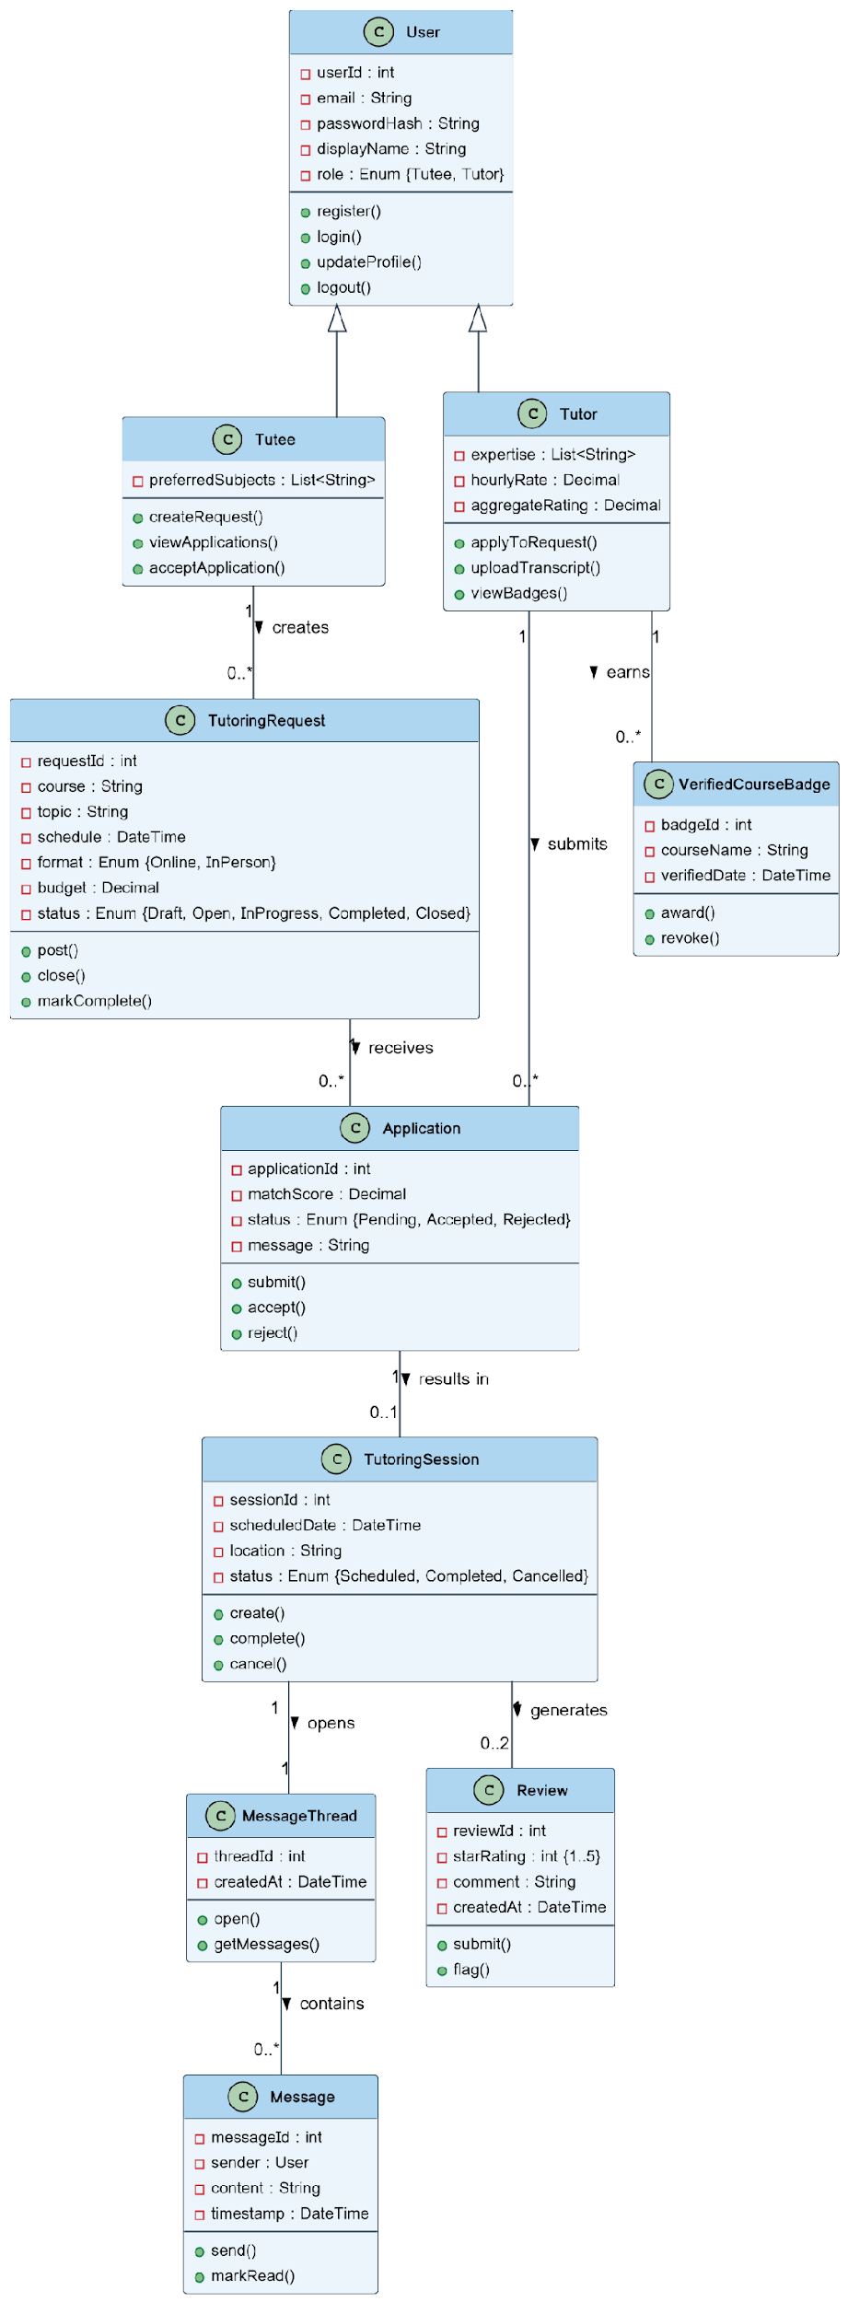
9.2 Dynamic – Behavioral Models
This segment explains the manner in which the objects of the system work together across time to achieve tasks. There is an activity diagram and a sequence diagram of each of the five main use cases that were identified in Section 8. Activity diagrams are the flow charts of the control in a starting point to an ending point that indicate the numerous decision paths in the workflow. Sequence diagrams depict the exchanges of messages between objects in a chronological sequence, and they represent the finer-grained interactions of the runtime. Also, a state machine diagram is given to the central TutoringRequest entity, which shows its event-driven lifecycle in all the use cases.
Event Diagram – TutoringRequest State Machine
The state machine diagram below is the model of the lifecycle of the TutoringRequest entity that is the key object in the TutorLink system. It illustrates the various states that a request may be in such as Draft, Open, In Progress, Completed and Closed and the events that cause a transition between these states. PostRequest event changes a request to Open, acceptApplication event changes it to In Progress and the markComplete event completes it to Completed. A closeRequest event may transfer the request to the Closed terminal state at any stage prior to completion. This one diagram represents the event-driven behavior that cuts across the entire related use cases.
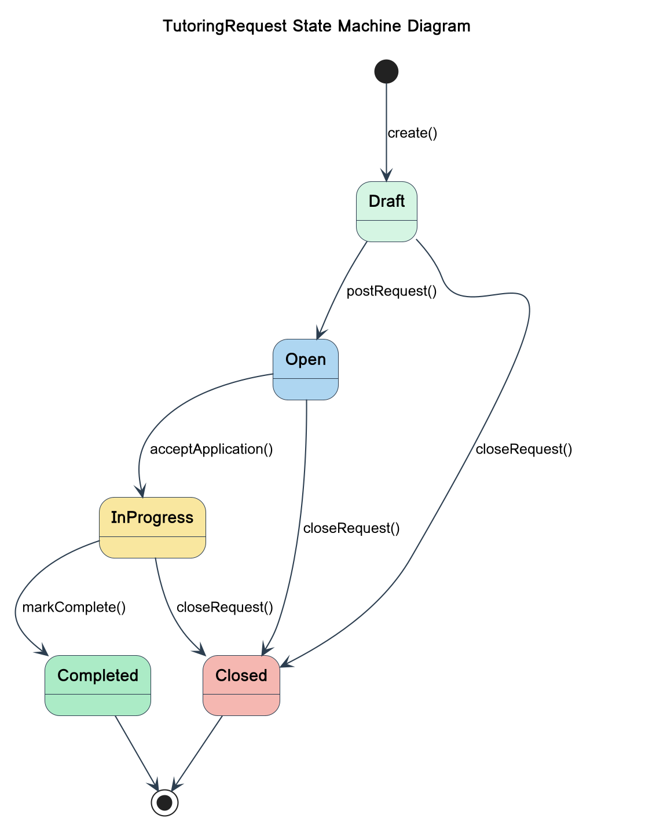
UC-01: Create Tutoring Request – Activity Diagram
The activity diagram below shows the flow of control of the Create Tutoring Request use case. It starts with the Tutee accessing the request creation page and the system displaying the input form. Once the Tutee completes the necessary fields and submits the system does the validation. In case of validation failure, the system will show error messages and the Tutee will amend the input. In case of validation, the system generates the request with an Open status, confirms the posting, and informs the corresponding Tutors.
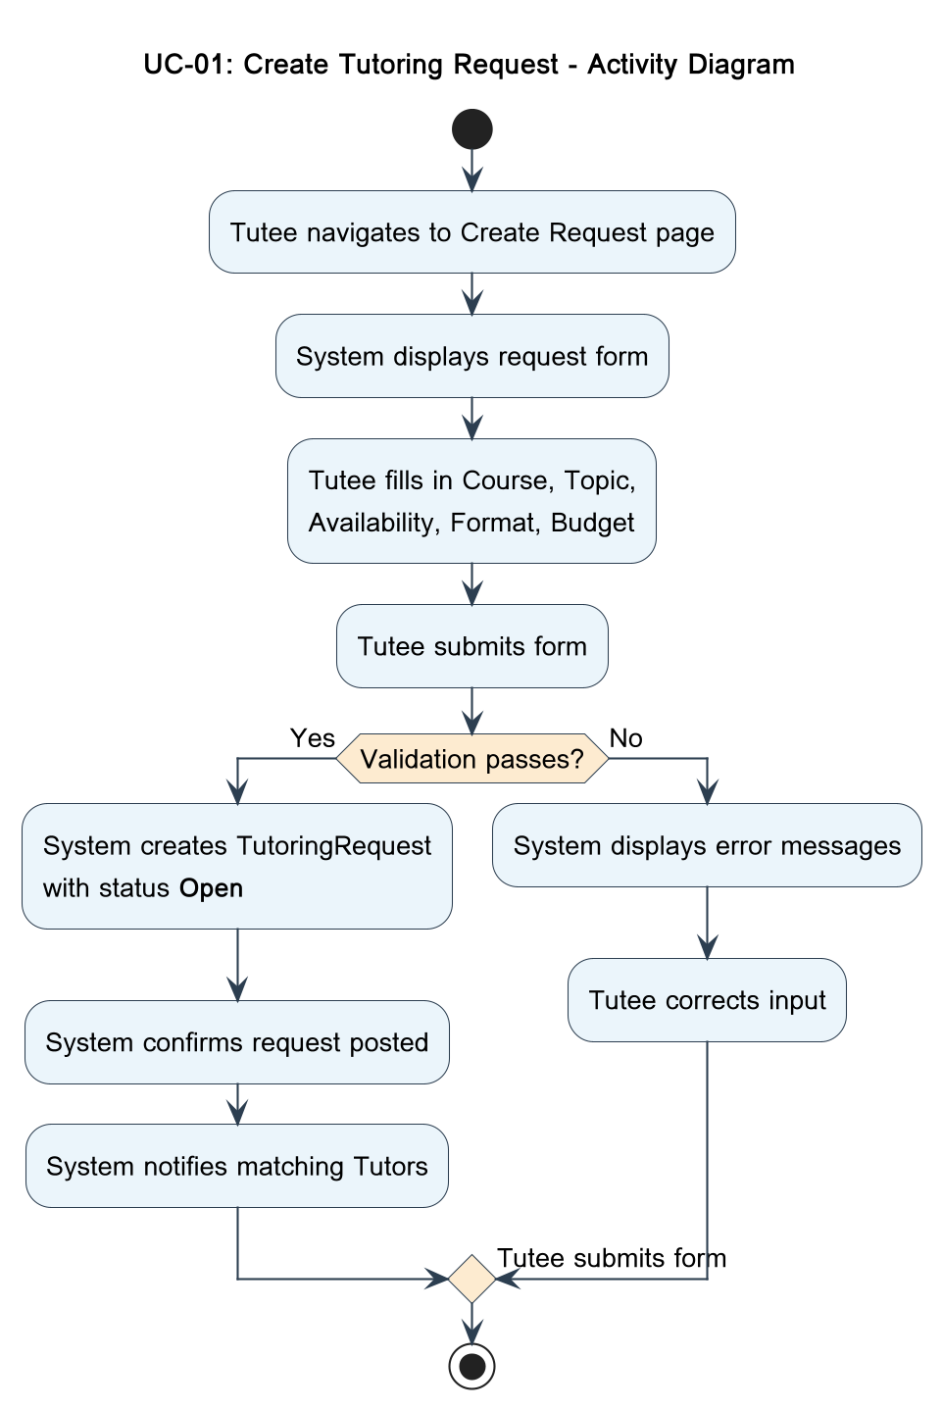
UC-01: Create Tutoring Request – Sequence Diagram
The runtime interactions to the Create Tutoring Request use case are modelled in the following sequence diagram. It displays the messages between the Tutee and the TutorLink Client and TutorLink Server, the Database, and the Notification Service. This flow starts with the Tutee clicking on the form, continues through form submission and server validation, and ends with the database insert and notification dispatch on successful creation.
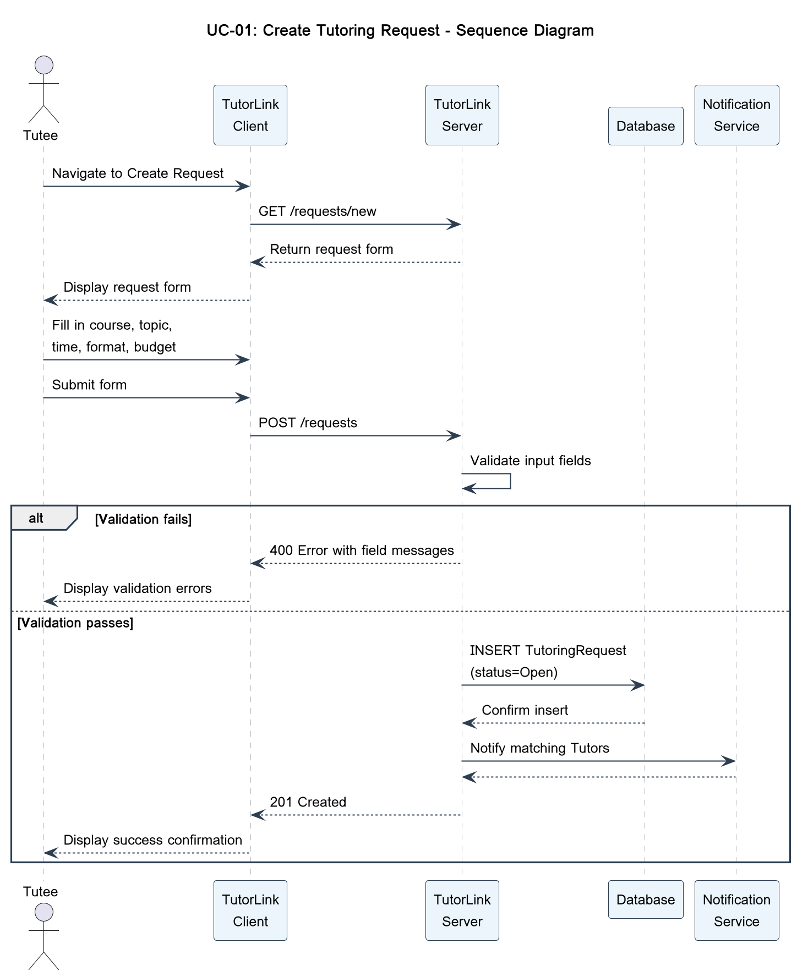
UC-02: Apply to Tutoring Request – Activity Diagram
The flow of control of the Apply to Tutoring Request use case is depicted in the following activity diagram. The Tutor goes through open requests, clicks on one of them to see its details, and the system verifies whether or not the Tutor has applied and the request is open. When both of the checks are successful, the system will generate the Application record and inform the Tutee.
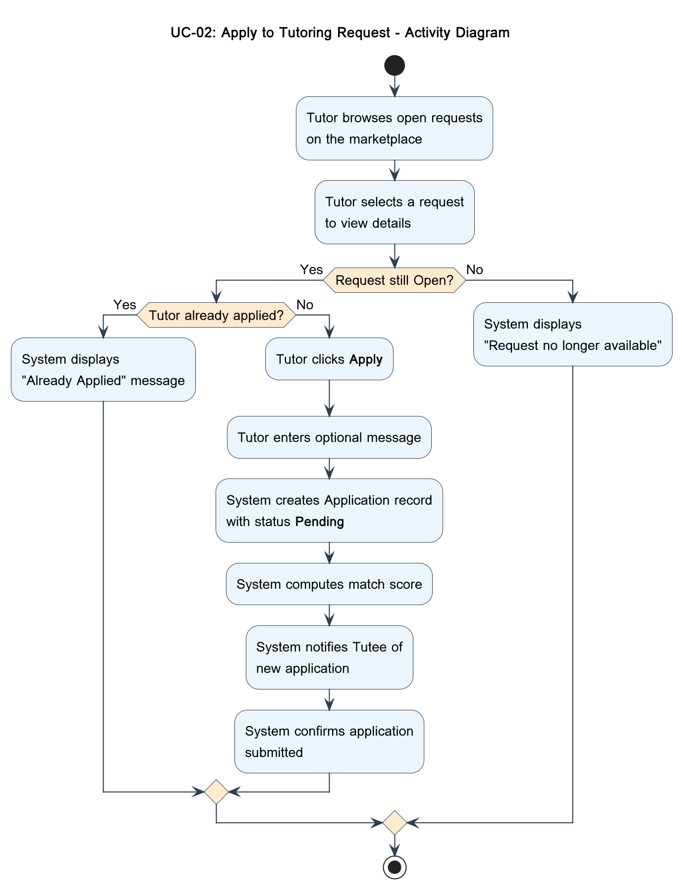
UC-02: Apply to Tutoring Request – Sequence Diagram
The runtime interactions of the Apply to Tutoring Request use case are shown in the following sequence diagram. It follows the messages of the Tutor browsing the marketplace, the server querying the database to get open requests, to the Tutor choosing a request and clicking Apply. The server will look into duplicate applications and then create the record and inform the Tutee.
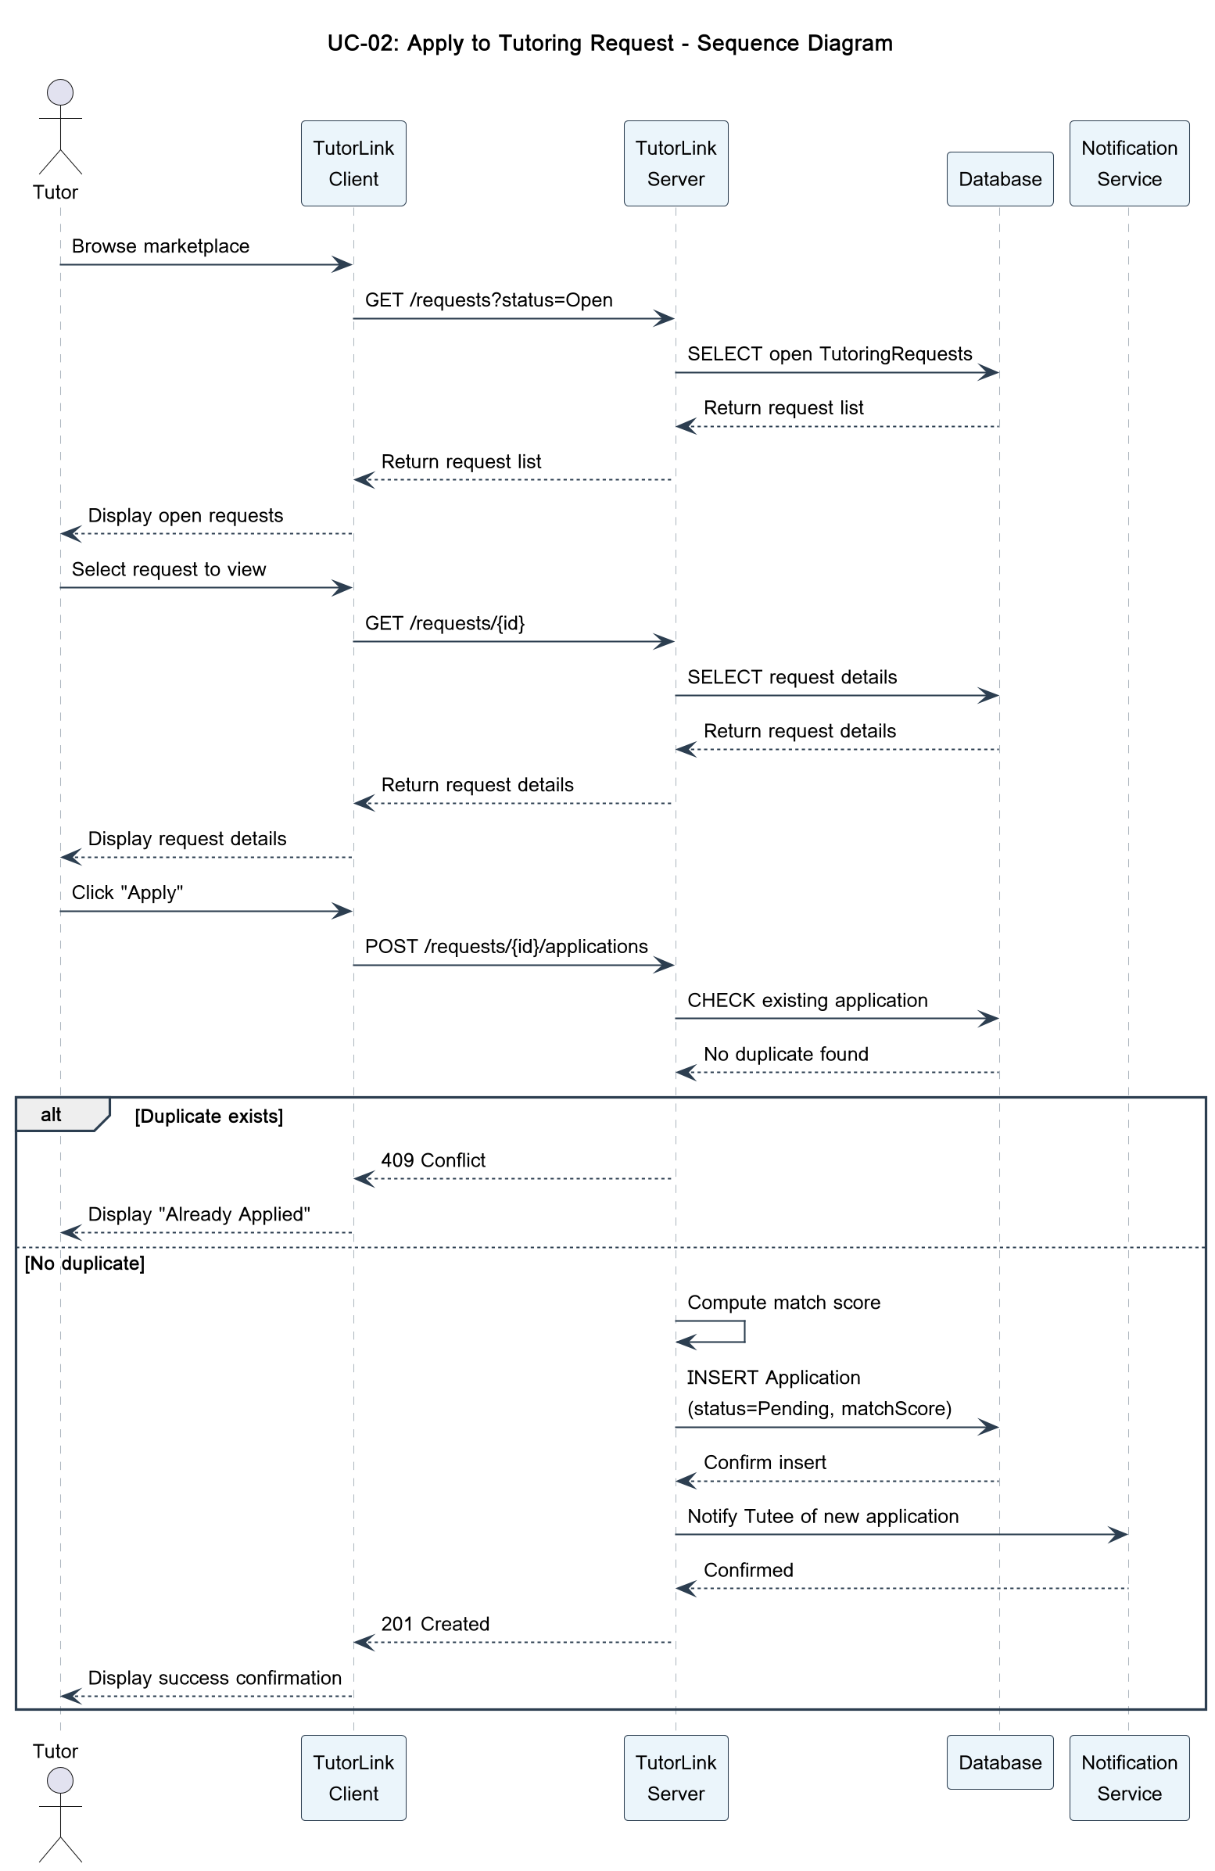
UC-03: Accept Application and Begin Session – Activity Diagram
The next activity diagram depicts the flow of control of the Accept Application and Begin Session use case. The Tutee looks at the list of ranked applications, reads profiles of the applicants and makes a decision on whether to accept or not. In case the Tutee accepts, the system changes the application status, transfers the request to In Progress, leaves the rest of the applications, forms a MessageThread, and informs the accepted Tutor. In case the Tutee rejects all the applicants, s/he can leave the request open or close it.
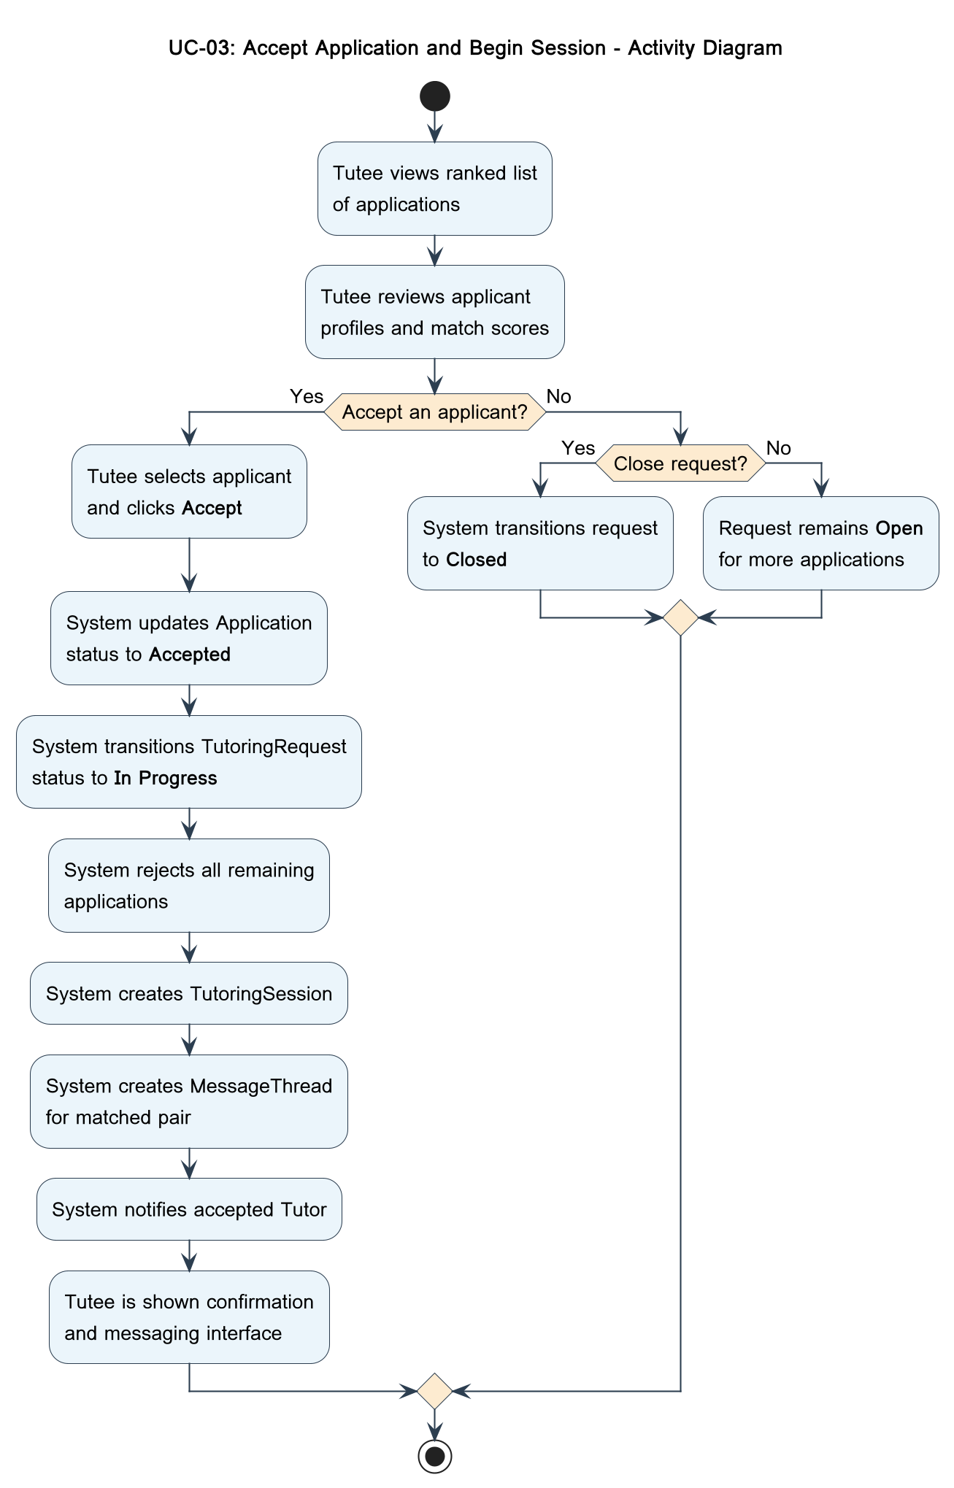
UC-03: Accept Application and Begin Session – Sequence Diagram
The sequence diagram below represents the most important workflow in the TutorLink system: the procedure through which a Tutee approves a Tutor to work with them. The interaction consists of the client application of the Tutee, TutorLink backend server, database, and notification service. The process starts when the Tutee makes the request of list of applications to his tutoring request. The server makes a query to the database and provides a rank list of the applicants and their calculated match scores. The Tutee then picks an applicant and activates the action of acceptance. This is processed by the server by changing the status of the selected application to Accepted, changing the status of the tutoring request to In Progress, rejecting all the remaining applications and establishing a new MessageThread between the matched pair. After the database verifies all the updates, the server sends a notification to the accepted Tutor and sends back a success response to the client of the Tutee, which in turn displays a confirmation and opens up the messaging interface.
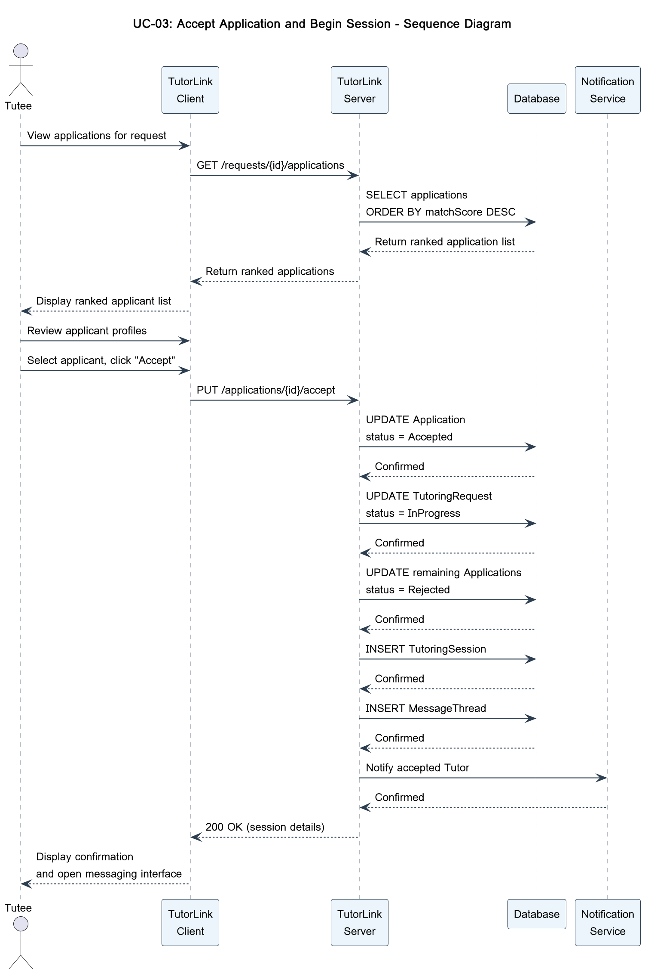
UC-04: Submit Review and Rating – Activity Diagram
The activity diagram below depicts the flow of control of the Submit Review and Rating use case. Both participants are prompted by the system after a session is marked complete. The user can provide a review by choosing a rating of stars and can leave a comment or leave it, whereby the system can send periodic reminders. When submitted, the system archives the review and recalculates the aggregate rating.
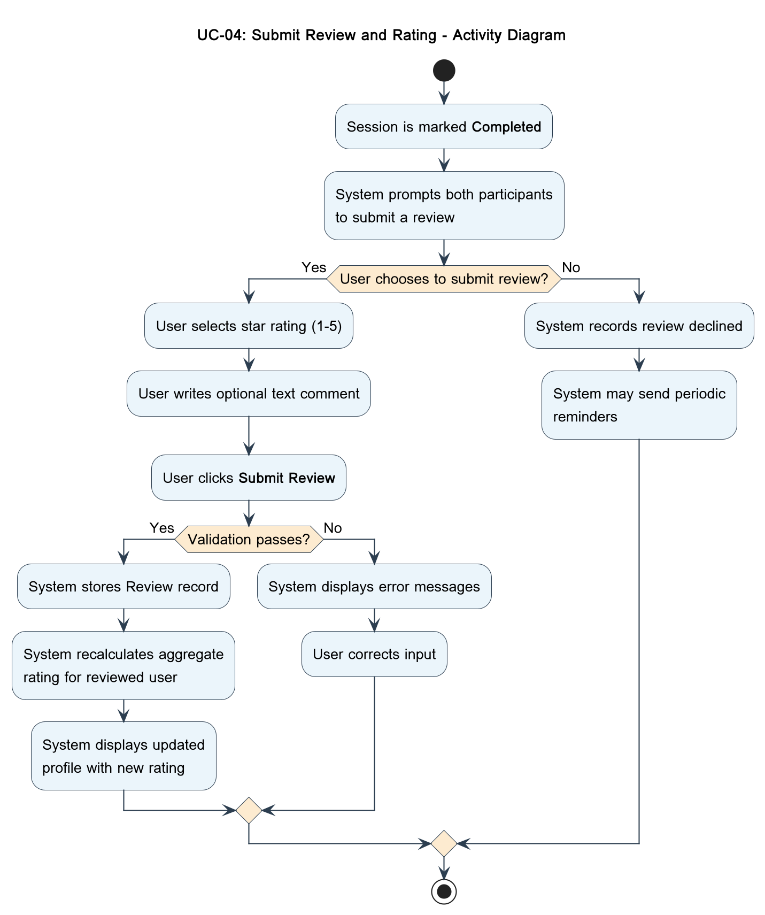
UC-04: Submit Review and Rating – Sequence Diagram
The next sequence diagram is a model of the runtime interactions of the Submit Review and Rating use case. It demonstrates how the server indicates the session as complete, where the user, via the client, fills in and submits the review form, and the server continues the review record and recalculates the aggregate average rating in the database.
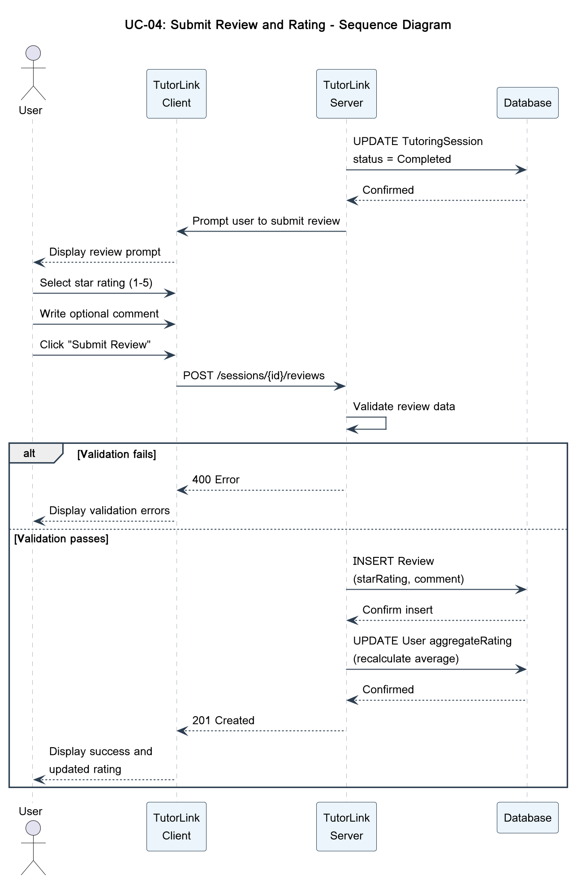
UC-05: Upload Transcript for Verified Course Badge – Activity Diagram
The Upload Transcript use case flow of control is depicted in the following activity diagram. The Tutor goes to his profile settings, clicks on the upload option, and the system displays the upload interface with a privacy notice. Once a file is uploaded by the Tutor, it checks the format and size. If invalid, an error is shown. In case of a valid one, the system adds the file to a special bucket, retrieves course names, issues Badges of Verified Courses, and shows the new profile.
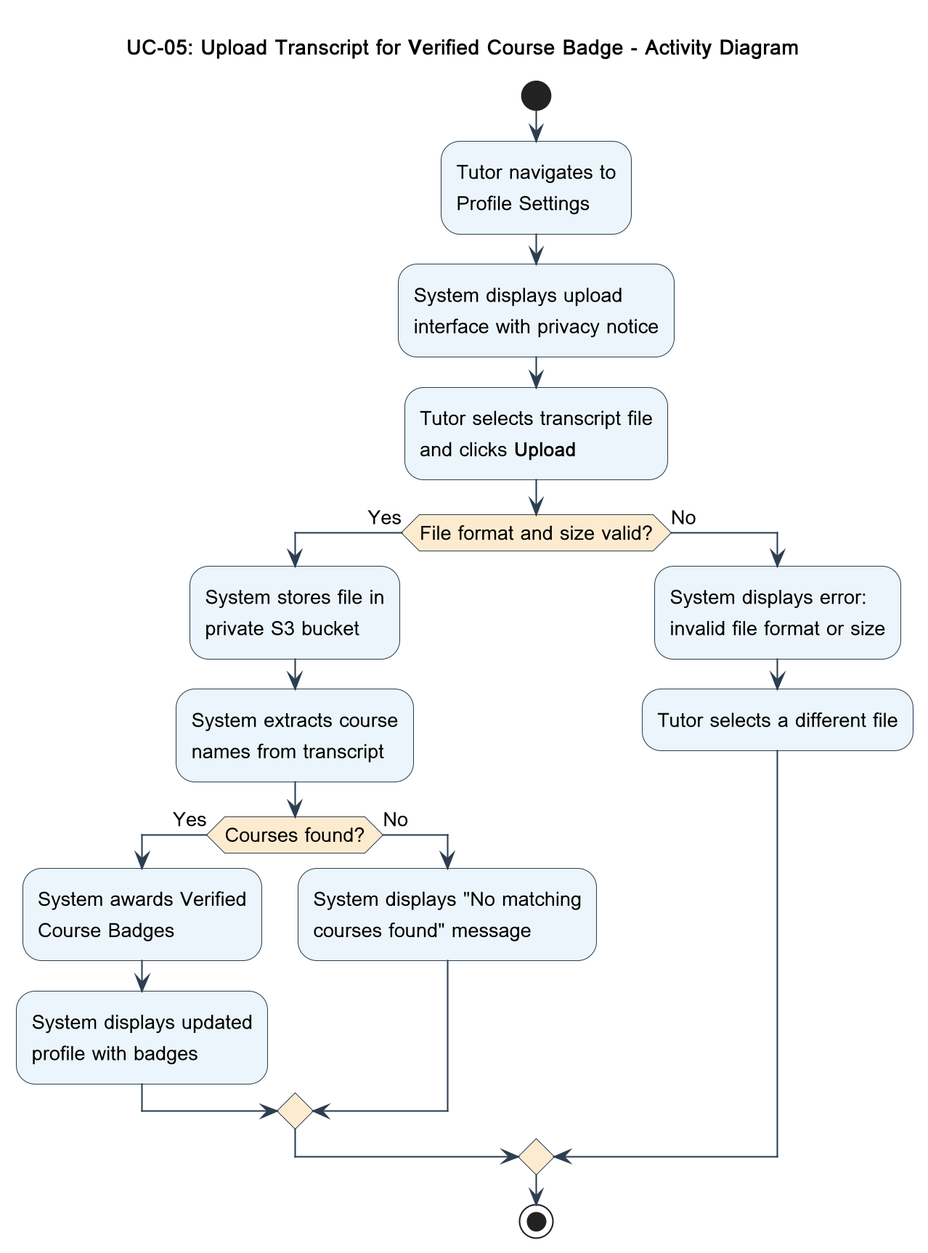
UC-05: Upload Transcript for Verified Course Badge – Sequence Diagram
The following sequence diagram is a model of the runtime interactions of the Upload Transcript use case. It follows the paths of the messages exchanged between the Tutor and profile settings, file upload to the server, server-side validation, storing in the private file bucket, extracting metadata, and eventually adding the records of VerifiedCourseBadge to the database. The File storage participant is added to demonstrate the communication with the private S3-compatible object store, which is in line with the FERPA requirements.
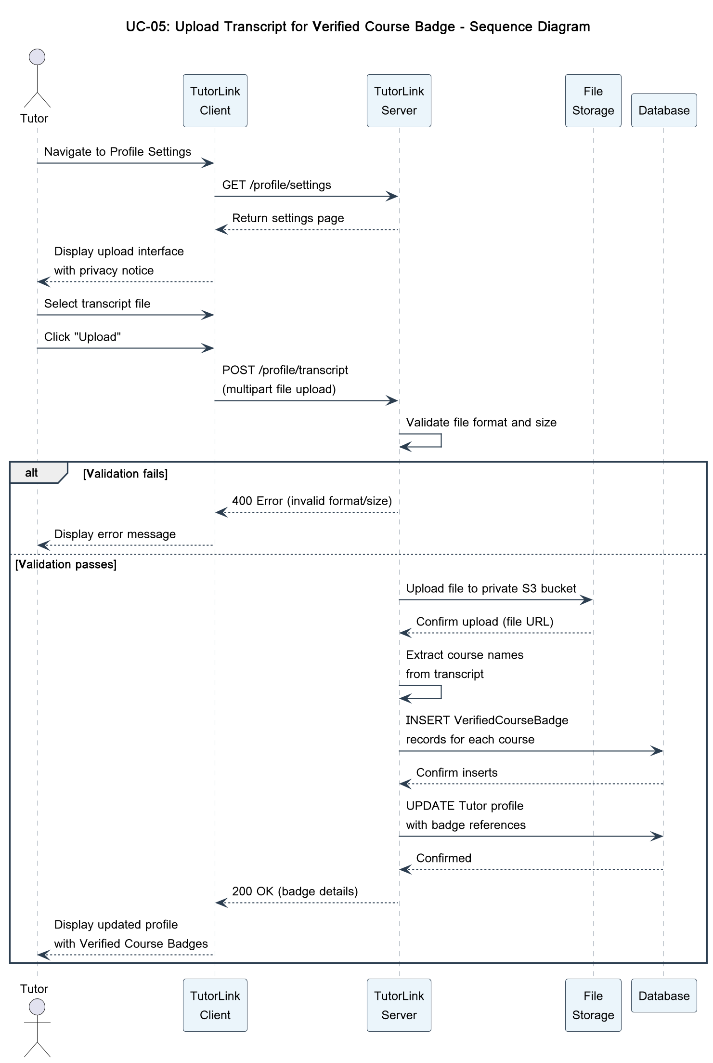
10. SYSTEM-WIDE DESIGN DECISIONS

10.1 Software Component Architectural Design

10.2 Software Architecture General Description

10.3 Software Item Components

10.4 Component Interface Identification

10.5 Software Component Concept of Execution

11. SOFTWARE ITEM DETAILED DESIGN

11.1 Structure

11.2 Static Relationship of Software Unit

11.3 Behavior

11.4 Concept of Execution

11.5 Interface Design

12. DEPLOYMENT ARCHITECTURE

12.1 Physical Deployment Architecture Diagram

13. EVOLUTION OF THE SSDS

14. RATIONALE

15. NOTES

16. APPENDICES

16.1 System Test Plan Requirements

16.2 Qualification Provisions

16.3 Requirements Traceability

16.4 Schedule Tracking

Hours
Artifact or Deliverable | Who (individual or Team) | Estimated | Actual | Difference
SSDS - Domain | For each team member
 | Summary for the Entire Team

Artifact or Deliverable | Who (individual or Team) | Estimated | Actual | Difference
SSDS - Requirements | For each team member
 | Summary for the Entire Team

Artifact or Deliverable | Who (individual or Team) | Estimated | Actual | Difference
SSDS - Analysis | For each team member
 | Summary for the Entire Team

Artifact or Deliverable | Who (individual or Team) | Estimated | Actual | Difference
SSDS - Design | For each team member
 | Summary for the Entire Team

Cumulative
Artifact or Deliverable | Who (individual or Team) | Estimated | Actual | Difference
Cumulative - Summary | For each team member
 | Summary for the Entire Team

16.5 Defect Tracking

Counts
Artifact or Deliverable | Who (individual or Team) | Estimated | Actual | Difference
SSDS - Domain | For each team member
 | Summary for the Entire Team

Artifact or Deliverable | Who (individual or Team) | Estimated | Actual | Difference
SSDS - Requirements | For each team member
 | Summary for the Entire Team

Artifact or Deliverable | Who (individual or Team) | Estimated | Actual | Difference
SSDS - Analysis | For each team member
 | Summary for the Entire Team

Artifact or Deliverable | Who (individual or Team) | Estimated | Actual | Difference
SSDS - Design | For each team member
 | Summary for the Entire Team

Cumulative
Artifact or Deliverable | Who (individual or Team) | Estimated | Actual | Difference
Cumulative - Summary | For each team member
 | Summary for the entire Team

16.6 Dictionaries

17. INDEX

